Table of Contents

1. Purpose and Goals 3
2. Design Review Process 4
A. District Boundaries 4
B. Certificate of Appropriateness 4
C. Penalties for Violations 5
D. Periodic Review 6
3. Architectural Character of the District 7
A. General Character 7
1. Land Use Activities 7
2. Natural Environment 7
3. Circulation Networks 8
4. Spatial Organization 8
5. Boundary Demarcations 8
6. Small-scale Elements 8
B. Austin Property Types 9
C. Architectural Styles of Austin 18
4. Local Historic District Design Standards 23
A. General 23
1. Retention of Historic Style: 23
2. Avoidance of False Historicism: 23
4. Architectural Barriers and Accessibility 24
5. Energy Efficiency 24
B. Rehabilitation of contributing Buildings 25
1. The Façade 25
2. Exterior Walls 25
3. Porches 25
4. Roofs 25
5. Windows and Screens 26
6. Doors 27
7. Chimneys 27
8. Mechanical Equipment 27
C. Additions to Contributing Buildings 27
1. Location and Height 27
2. Design and Style 30
3. Exterior Walls 30
4. Porches 31
6. Windows and Screens 31
7. Doors 31
8. Chimneys. 31
D. NON-CONTRIBUTING BUILDINGS 31
E. NEW CONSTRUCTION 32
1. Orientation, Set-Backs, and Height 32
2. Design and Style 32
3. Exterior Walls 33
4. Porches 33
5. Roofs 33
6. Windows and Screens 33
7. Doors 33
8. Chimneys 34
9. Garages & Accessory Buildings 34
10. Independent Fences and Walls 34
11. Landscaping 34
Appendix A: Glossary 36
Appendix B: Secretary of the Interior’s Standards for Rehabilitation 41
Appendix C: Treatment Guidelines 42
Appendix D: Additional Resources 54

1. Purpose and Goals

Design Standards serve to preserve and protect areas of historical and architectural importance, as well as the overall visual characteristics of the District. The following Design Standards have been developed to provide guidance and support for the repair, rehabilitation, preservation and restoration of historic buildings within the Historic District, and to ensure that new construction is compatible with the architectural character of the District. This document is a tool for property owners, tenants, contractors, design professionals, realtors or anyone else planning a change to the exterior or site of a building or new construction within the district; as well as the Historic Landmark Commission in their evaluation of whether to grant a Certificate of Appropriateness for any project covered by these Standards.

The goals of the Design Standards are to:
- Preserve the architectural heritage of the District through retention and preservation of historic buildings;
- Discourage demolition of contributing buildings and buildings easily restored to contributing character;
- Support historic building preservation by providing guidance in building maintenance and repair;
- Ensure that alterations to existing buildings are compatible with the character and scale of the structure and the district;
- Support sustainable design by providing guidance to improve energy efficiency and building performance;
- Avoid false historicism by preventing the addition of elements from a different architectural period than the contributing structure;
- Establish design criteria for new construction within the District to ensure that new construction will be compatible with the historic character and scale of neighboring structures in the District; and
- Stabilize property values by maintaining existing building stock and defining compatible new construction;

2. Design Review Process

A. District Boundaries
These Design Guide Lines govern the designated Historic District bound by:
- Fill in here with bullet points. Include a map if desired.

B. Certificate of Appropriateness
Purpose of the Certificate of Appropriateness
The Certificate of Appropriateness review process ensures that proposed changes to a property in the historic district comply with these Design Standards. A Certificate of Appropriateness must be granted before a building permit will be issued by the City.

Activities that Require a Certificate of Appropriateness
The design review process does not require property owners to proactively make changes to their properties, such as restoring buildings to their historic appearance. The design review process only comes into play once a property owner initiates a construction project that is substantial enough to require a Certificate of Appropriateness.

According to Sections 25-11-2 and 25-11-212 of the City of Austin Land Development Code, a person must obtain a Certificate of Appropriateness to change, restore, remove, or demolish an exterior architectural or site feature of a structure that is contributing to the historic district.

A Certificate of Appropriateness is NOT required for:
- Remodeling the interior of the building;
- Routine maintenance projects, provided that work follows the treatment guidelines set forth in Appendix C to ensure that the work does not affect the historic character of the resource. This may include painting, repointing of masonry, foundation repair, etc., or
- Remodeling of non-contributing buildings.

A Certificate of Appropriateness IS required for:
- Replacing siding, porches, doors, windows, or roofing materials;
- Exterior alterations to existing buildings and sites including, but not limited to, the construction of additions, decks, pools, or the installation of new windows, doors or roofs;
- Demolition of existing buildings or parts of buildings;
- New construction;
- Relocation of existing buildings into or out of the district; or
- Landscape changes requiring a City permit.

The City Historic Preservation Office will review applications to determine if a Certificate of Appropriateness is necessary.

Process for Obtaining a Certificate of Appropriateness
Applications for a Certificate of Appropriateness must be submitted to the City Historic Preservation Office at least 21 days before a scheduled Historic Landmark Commission meeting. The application form may be obtained from the City Historic Preservation Office or the City of Austin website. Property owners may contact City staff in the early planning stages of a project for assistance in interpreting the Standards, suggesting solutions to problems, and explaining the review process and requirements. The Historic Preservation Office staff can also provide on-site consultations and other technical assistance. The City Historic Preservation Office conducts a preliminary review of the application for a Certificate of Appropriateness and may contact the applicant for additional information, or to suggest changes to the application.

Depending on the scale of the project, the application for a Certificate of Appropriateness will be evaluated by either the City Historic Preservation Officer or the City of Austin Historic Landmark Commission, per the criteria below.

The City Historic Preservation Officer may administratively approve applications for Certificates of Appropriateness for the following:
- Accurate restoration or reconstruction of a documented missing historic architectural element of the structure or site;
- Changes which do not affect the appearance of the structure or site from an adjacent public street, limited to:
- Demolition of garages, sheds, carports, or other outbuildings that are non-contributing;
- Construction of a ground-floor, one-story addition or outbuilding with less than 600 square feet of gross floor area;
- Two-story additions to the rear of two-story houses; or
- A pool, deck, fence, back porch enclosure, or other minor feature.

The Historic Landmark Commission must hear all other Certificates of Appropriateness.

The Historic Preservation Office or Historic Landmark Commission may grant the Certificate of Appropriateness if the application conforms to these Design Standards. If the Certificate of Appropriateness is not granted, the Historic Landmark Commission may require the applicant to modify the proposed work and revise the application accordingly. Appeal of a denial of a Certificate of Appropriateness may be made to the appropriate land use commission and, if denied, to the City Council.

Responsibilities of the Applicant
The responsibility for demonstrating that the proposed project meets these Design Standards lies with the applicant. The applicant shall submit sufficient photographs or physical documentation to demonstrate that the proposed project meets these standards. The Historic Preservation Office or Historic Landmark Commission may require additional documentation as necessary.

The historic property may also be designated a Recorded Texas Historic Landmark (RTHL) or a State Archeological Landmark (SAL), which requires review by the Texas Historical Commission (THC). In this case, the applicant is responsible to submit the proposed work to the THC for review independent of the Local Historic District review process.

C. Penalties for Violations
Any person or corporation who violates provisions of the Standards is subject to the same criminal misdemeanor and/or civil penalties that apply to any other violation of the City Code.

D. Periodic Review
These Design Standards are not intended to be static. It is subject to periodic review, revision, and amendment. The process for revising or amending the Design Standards shall follow the process set forth for Neighborhood Plans, as described in City of Austin Code §25-1-802, which states:

The director shall conduct a general review of a neighborhood plan not earlier than five years after the adoption of the plan and may recommend amendments of a plan to the Planning Commission and council. The director shall include neighborhood stakeholder input in the review process.

3. Architectural Character of the District
Character Photo 1 | Character Photo 2 | Character Photo 3 | Character Photo 4
Title 1 | Title 2 | Title 3 | Title 4

A. General Character
The following description of the overall landscape and streetscape of the District is founded upon the National Register Bulletin Historic Residential Suburbs: Guidelines for Evaluation and Documentation for the National Register of Historic Places.

1. Land Use Activities
Historic Land Use Patterns
- In the historic period, residential properties were intermixed with commercial and institutional properties.
Current Land Use Patterns
- Today, residential properties are intermixed with commercial and institutional properties.
Multi-family Residential Land Use
- The district historically included multi-family residences intermixed with single-family residences. [If appropriate, describe the locations of multi-family residences, such as along major thoroughfares or at major intersections.]
Commercial Land Use
- The district historically included commercial properties intermixed with residential properties. [If appropriate, describe the locations of commercial properties, such as along major thoroughfares or at major intersections.]
Institutional Land Use
- The district historically included institutional properties intermixed with residential properties. [If appropriate, describe the locations of institutional properties, such as along major thoroughfares or at major intersections.]
Open Space
- [Discuss any parks.]
- [Discuss any trails or greenbelts.]
- [Discuss any community gardens.]
- [Discuss any communal esplanades, median parks, or roundabouts.]
- [Discuss any significant open spaces located on private property.]

2. Natural Environment
Topography
- The topography of the district is gently sloping towards Lady Bird Lake with steeper drops between 5th and 6th Streets as well as between Holly and Canterbury Streets.
Trees and Natural Landscape
- [Discuss any open space where the landscape remains natural, such as within parks or along greenbelts or waterways.]
- [Discuss any significant trees or clusters of trees.]
Designed Landscape
- The designed landscape elements within the district are varied.
- [Note: Additionally, discuss any infrastructure elements that are significant to the designed landscape, such as retaining walls, culverts, bridges, etc.]

3. Circulation Networks
Street Patterns
- The street pattern generally follows a grid, but several streets curve or dead-end in response to the natural features and topography along the shore of Lady Bird Lake and the surrounding area of Festival Beach Park.
Major Thoroughfares
- Major thoroughfares that border the District include Interstate 35, Cesar Chavez, Chicon, Holly, and 6th St.
Alleys
- Alleys are common in an East/West alignment between most of the streets in the District.
Sidewalks
- Sidewalks are present in some locations within the district, but not consistently. [Discuss where.]

4. Spatial Organization
Subdivision of Lots
- Although lots are generally rectangular, they vary in size.
Organization of Lots
- Houses tend to have front porches while garages are detached and at the rear of the lot along with other accessory buildings.
Setbacks
- Set backs are regularly 25 feet from the front lot lines, while many accessory structures are grandfathered directly along the rear or alley lot border.

5. Boundary Demarcations
District Boundaries
- The district’s boundaries are based on a variety of features including major thoroughfares to the North, West, and East, while bordered in the South by Lady Bird Lake.
Property Boundaries
- Include streets, alleys, parks, fences, walls, and vegetation.
Fencing
- Fencing on individual properties varies throughout the district.
- Wood, chain link, iron work, stone and brick walls are all to be found in the district.
Retaining walls
- Retaining walls exist along the steeper drops in elevation including the 5th and 6th Street drop as well as the one between Holly and Canterbury Streets. Materials used vary, but the most common are limestone and cinderblock.

6. Small-scale Elements
Signage and Sculptures
- If applicable, describe.
Lighting
- If applicable, describe.
Street Furniture
- If applicable, describe.

B. Local Architectural type and character
Property types and architectural styles are useful categories for analyzing general types of historic resources commonly found within historic districts. The inventory of historic properties (Appendix C of the local historic district application) provides a list of the specific property types and architectural styles found within the historic district. The following analysis sets forth typical character-defining features of property types and architectural styles. Note that many examples of historic resources do not strictly fit any property type or architectural style classification. Similarly, a typical example of a property type or architectural style may exhibit some of the character-defining features below, but not all. Other examples of historic resources may combine eclectic elements from several property types or architectural styles. This analysis of property types and architectural styles seeks to find commonalities among general trends, though the inventory of resources within a historic district inevitably will include exceptions.

Property type designation is primarily based upon the function intended for the building at the time of its construction. Because form follows function, properties that share a use-type often share similarities in floor plan, roof form, size, and scale. Similar property types often are clustered together due to a variety of factors influencing development, including proximity to transportation, property values, desire for visibility versus desire for privacy, and convenience. Property Type Classifications are based on a combination of the resource’s original use or function, stylistic influences, and form/plan type. Although this system works well for the majority of the identified resources, some properties are unique and may not fall under a single standard property type classification. Standard definitions for property types are set forth by the National Park Service in Bulletin No. 16a, How to Complete the National Register Registration Form.

Vernacular Linear Plans (Two Room, Center Passage, Shotgun)

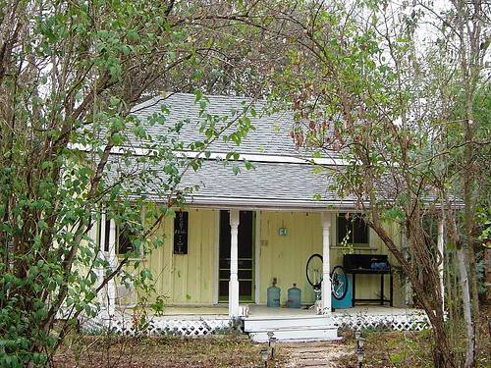 | 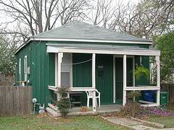
Center Passage House. | Shotgun Plan House.

Vernacular-plan houses were typically constructed prior to arrival of the railroad using handmade or locally manufactured construction materials. These houses typically are one or one-and-a-half stories in height with a one-room deep floor plan and a side-gabled, front-gabled, or hipped roof form. Historic additions to the rear of the original structure are common. Because they often pre-date the surrounding construction, they may be set further back or closer to street than surrounding, later buildings. Stone walls or agriculture-related outbuildings or small-scale structures may be present. Although not original, detached garages may have been added within the District’s period of significance.

- Exterior Walls: May be constructed with wood (often board-and-batten), log, fachwerk, stone, or brick. Surface may be finished with paint or stucco, or may be unfinished.
- Foundation: Pier and beam, typically with brick or wood piers.
- Porches: Typically full-width with a shed roof and a wood porch floor.
- Roofs: Originally usually wood shingle, metal shingle, corrugated metal, or standing seam metal.
- Windows: Double-hung wood-sash, often with a two-over-two or four-over-four configuration.
- Doors: Typically wood without glazing.
- Chimneys: Original stone or brick masonry chimneys may be located at either gable-end exterior wall.

L-Plan

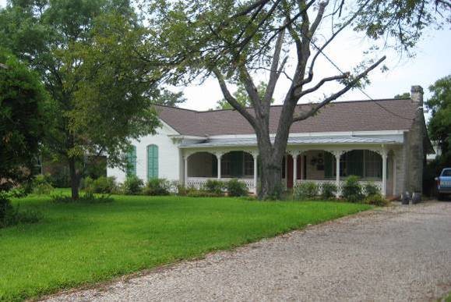 | 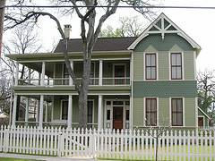
One-Story L-plan House. | Two-Story L-plan House.

Most L-plan houses were constructed after the arrival of the railroad using milled lumber with prefabricated decorative elements. These houses typically are one or one-and-a-half stories in height with an L-shaped floor plan and a cross-gabled roof form. Historic additions to the rear of the building are typical. L-plan houses are usually set back with a front yard. Wood or cast iron fences may be present. Original barns or sheds may be present. Although not original, detached garages may have been added within the district’s period of significance.

- Exterior Walls: Typically constructed with wood siding or wood shingles finished with paint, although occasionally brick or stone.
- Foundation: Pier and beam, typically with brick or wood piers.
- Porches: Typically partial-width set within the interior angle of the L-plan. Often feature decorative wood detailing in the Queen Anne Style, such as turned porch posts, turned balusters, and spindle friezes. Mid-twentieth century examples may employ Minimal Traditional Style detailing.
- Roofs: Originally usually metal shingle, corrugated metal, or standing seam metal. Often feature decorative wood detailing in the Queen Anne Style, such as bargeboards.
- Windows: Double-hung wood-sash, often with a two-over-two or four-over-four configuration. Often feature projecting bay windows or dormer windows.
- Doors: Typically paneled wood with glazing.
- Chimneys: Original stone or brick masonry chimney or metal stovepipe typically located at interior of floor plan or at gable ends.

Modified L-Plan

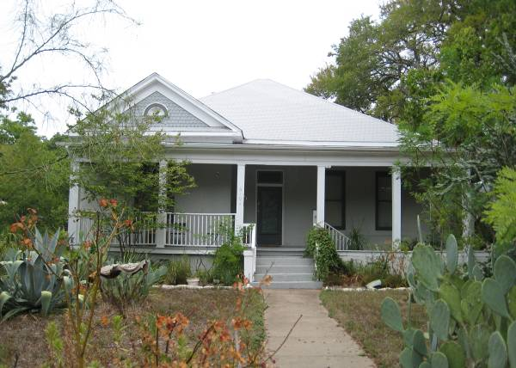 | 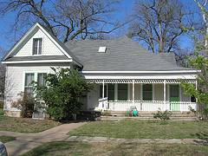
Modified L-plan House. | Modified L-plan House.

Modified L-plan houses typically were constructed after the arrival of the railroad using milled lumber with prefabricated decorative elements. The modified L-plan house is one or one-and-a-half stories. The primary difference between an L-plan house and a modified L-plan house is the roof form – while an L-plan house has a cross-gabled roof, a modified L-plan house has a gable-on-hip roof. Also, in an L-plan house, the porch typically has a shed roof, while in a modified L-plan house, the porch is recessed under the main, hipped roof form. In Austin, modified L-plan houses typically are set back with a front yard. Wood or cast iron fences may be present. Although not original, detached garages may have been added within the district’s period of significance. Original barns or sheds may be present.

- Exterior Walls: Typically constructed with wood siding or wood shingles finished with paint, although occasionally brick or stone.
- Foundation: Pier and beam, typically with brick or wood piers.
- Porches: Typically partial-width set within the interior angle of the L-plan. Wraparound porches common. Often feature decorative wood detailing in the Queen Anne Style, such as turned porch posts, turned balusters, and spindle friezes. Mid-twentieth century examples may employ Minimal Traditional Style detailing.
- Roofs: Typically a gable-on-hip or a gable-on-pyramidal. Originally usually metal shingle, corrugated metal, or standing seam metal. Often feature decorative wood detailing in the Queen Anne Style, such as bargeboards.
- Windows: Double-hung wood-sash, often with a two-over-two or four-over-four configuration. Often feature projecting bay windows or dormer windows.
- Doors: Typically paneled wood with glazing.
- Chimneys: Original stone or brick masonry chimney or metal stovepipe typically located at interior of floor plan.
Pyramidal-roof Square Plan/Hipped-roof Square Plan

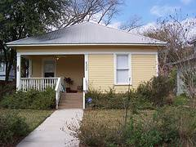 | 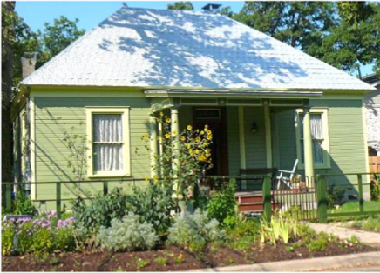
Pyramidal-roof Square Plan House. | Hipped-roof Square Plan House.

This nationally popular folk house form was typically constructed after the arrival of the railroad using milled lumber with prefabricated decorative elements. These houses are one or one-and-a-half stories in height, with a square footprint creating a “boxy” exterior appearance, topped by a pyramidal or hipped roof form. Historic rear additions are typical. In Austin, these houses typically are set back with a front yard. Wood or cast iron fences may be present. Although not original, detached garages may have been added within the district’s period of significance. Original barns or sheds may be present.

- Exterior Walls: Typically constructed with wood siding or wood shingles finished with paint, although occasionally brick or stone.
- Foundation: Pier and beam, typically with brick or wood piers.
- Porches: Typically recessed under the main roof form. Often feature decorative wood detailing in the Queen Anne Style, such as turned porch posts, turned balusters, and spindle friezes.
- Roofs: Originally typically metal shingle, corrugated metal, or standing seam metal. Often feature decorative wood detailing in the Queen Anne Style, such as bargeboards.
- Windows: Double-hung wood-sash, often with a two-over-two or four-over-four configuration. Often feature projecting bay windows or dormer windows.
- Doors: Typically paneled wood with glazing.
- Chimneys: Original stone or brick masonry chimney or metal stovepipe typically located at interior of floor plan.

Bungalow

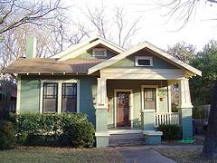 | 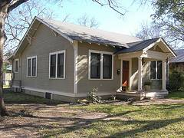
Front-gabled Bungalow. | Side-gabled Bungalow.

The bungalow is a nationally popular house form that was always constructed after the arrival of the railroad, and typically constructed after local popularization of the automobile. Bungalow plans were standardized, often distributed through lumber companies. Bungalows are usually one-story in height, but sometimes, one-and-a-half or two-stories. Floor plans usually are organized with the living room, dining room, and kitchen aligned on one side of the house, and the bedrooms aligned on the other side, so that corridor space is minimized. In Austin, bungalows typically are set back from the street, with a front yard. Concrete sidewalks or driveway runners may be present. Because bungalows often were constructed after the advent of the automobile, a detached garage may be associated with the house, and/or a porte cochere attached to a side façade of the house.

- Exterior Walls: Typically constructed of milled lumber with wood siding finished with paint, but sometimes constructed of brick or stone masonry.
- Foundation: Typically pier and beam with brick piers, but sometimes concrete stem wall and footing.
- Porches: Typically partial-width with a front-gabled roof form and wood or concrete porch floor. Often feature Craftsman Style tapered porch piers, sometimes on wood or stone bases. However, sometimes feature Classical Revival Style, Tudor Revival Style, Spanish Colonial Revival Style, or Mission Revival Style porch supports and detailing.
- Roofs: Roof form typically front- or side-gabled, with deep eaves. Originally usually standing seam metal or asphalt or asbestos shingle. Often detailed with exposed rafter ends.
- Windows: Double-hung wood-sash, usually with a one-over-one configuration. Often feature wood screens with geometric detailing on the upper sash with Craftsman Style or Prairie Style motifs. Eyebrow gable windows may be present.
- Doors: Typically paneled wood with glazing.
- Chimneys: Typically brick masonry chimney located at the side elevation.

American Four-Square Plan

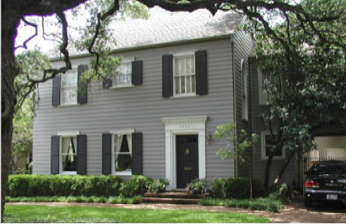 | 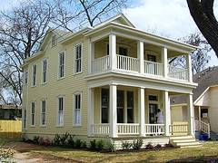
American Four-square House. | American Four-square House.

American four-square houses were always constructed after the arrival of the railroad, and often constructed after local popularization of the automobile. American four-square houses are usually two- or two-and-a-half stories in height. Floor plans typically include four rooms on each floor, with entry into one of the front rooms on the ground floor. In Austin, these houses typically are set back with a front yard. Concrete sidewalks or driveway runners may be present. They often include a detached garage and/or a porte cochere attached to a side façade.

- Exterior Walls: Typically brick masonry, but sometimes constructed of milled lumber with wood siding finished with paint.
- Foundation: Pier and beam, typically with brick piers.
- Porches: Typically full-width with a front-gabled or shed roof form and wood or concrete porch floor. Often feature Craftsman Style tapered porch piers, sometimes on wood or stone bases. However, sometimes feature Classical Revival Style, Tudor Revival Style, Spanish Colonial Revival Style, or Mission Revival Style porch supports and detailing.
- Roofs: Roof form typically low-pitched hipped or pyramidal. Originally usually standing seam metal or asphalt or asbestos shingle.
- Windows: Double-hung wood-sash, usually with a one-over-one configuration. Often feature wood screens with geometric detailing on the upper sash with Craftsman Style or Prairie Style motifs.
- Doors: Located asymmetrically, offset to one side of front façade. Typically paneled wood with glazing.
- Chimneys: Typically brick masonry chimney located at side façade.

Two-Story Center Passage Plan

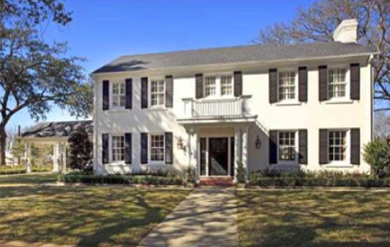 | 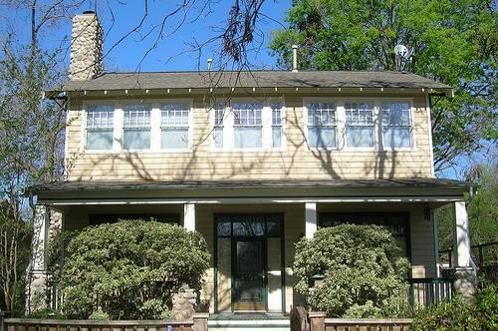
Two-Story Center Passage Plan, Colonial Revival Style. | Two-Story Center Passage Plan, Craftsman Style.

Most examples of the two-story center passage plan house in Austin were constructed after the arrival of the railroad, and many were constructed after local popularization of the automobile. This house form is two- or two-and-a-half stories in height, featuring a floor plan with a central entry hall on the ground floor, leading to a central stair. These houses usually are set back with a front yard. Concrete sidewalks or driveway runners may be present. A detached garage and/or a porte cochere may be associated with the main house.

- Exterior Walls: Typically brick masonry, but sometimes constructed of milled lumber with wood siding finished with paint.
- Foundation: Pier and beam, typically with brick piers.
- Porches: Either partial-width or full-width, with a projecting front-gabled, flat, or shed roof form. Porch floors may be wood or concrete. Often feature Classical Revival Style, Tudor Revival Style, Spanish Colonial Revival Style, Mission Revival Style, Prairie Style, or Craftsman Style porch supports and detailing.
- Roofs: Roof form typically low-pitched hipped or pyramidal. Originally usually standing seam metal or asphalt or asbestos shingle.
- Windows: Double-hung wood-sash, usually with a one-over-one configuration. Often feature wood screens with geometric detailing on the upper sash with Craftsman Style or Prairie Style motifs.
- Doors: Located at the center of the front façade. Typically paneled wood with glazing.
- Chimneys: Typically brick masonry chimney located at side façade.

Domestic Outbuildings

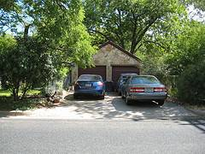 | 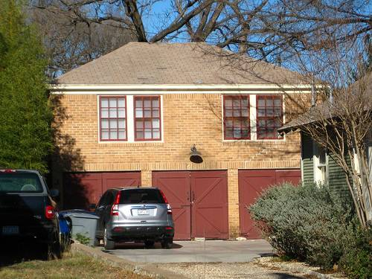
Detached Garage. | Detached Garage Apartment.

The detached garage is the overwhelmingly most common historic domestic outbuilding found in Austin. Detached garages typically are one-story in height with a rectangular footprint and a single, open interior space. Garage apartments may be two stories in height, with an open garage space on the ground floor and a living space above. Some domestic properties retain agricultural outbuildings, such as barns or sheds, which pre-date the residential development of the surrounding neighborhood. Domestic outbuildings typically are sited at the rear of the lot, behind the main house.

- Exterior Walls: Most commonly wood siding or board-and-batten, but may be brick or stone.
- Foundation: Usually poured concrete slab, but some examples have no foundation, only a dirt floor.
- Porches: Domestic outbuildings seldom include porches.
- Roofs: Roof form most often front-gabled, but may be side-gabled or hipped. Roofing material usually matches the associated main house.
- Windows: Usually limited to side façades. Window materials and configuration typically match associated main house.
- Doors: In garages, overhead rolling doors are common, but original hasp-hung doors or hinged doors may be present.
- Chimneys: Domestic outbuildings seldom include chimneys.

C. Architectural Styles of Austin
Not all historic resources are exemplary of a particular architectural style. On the other hand, some eclectically combine several styles (especially early twentieth century Revival styles). Other historic resources were constructed during a period of stylistic transition, featuring some elements of a more traditional style (such as Minimal Traditional) combined with other elements of a more progressive style (such as Ranch or Modern). Architectural styles found within the Historic District are listed below. Architectural styles can be integral to the form of the building and related to the property type, or can be displayed through decorative ornament applied to a building. Some typical character-defining features of each architectural style are listed. A resource does not need to display all of the listed character-defining features to be considered a good example of a style; however, when these character-defining features are intact, they must be preserved in order to preserve the overall character of the architectural style. Resources also may exhibit different stylistic elements due to changes over time. If these changes occurred during the historic district’s period of significance, such changes should be respected and possibly retained during restoration or rehabilitation projects. Photos of examples of each style are provided with each property type section.

Architectural styles can be integral to the form of the building or manifested in decorative ornament applied to a building. While property types often are clustered together, architectural styles may be very eclectic within a grouping. Architectural styles often vary depending on date of construction or historic use. Some architectural styles were very popular for a confined period of time but then declined in popularity, but because many architectural styles—especially “Revival” styles—have their roots in earlier architectural styles, they are used throughout the historic period rather than in one confined era. Standard classifications for architectural styles are set forth by the National Park Service in Bulletin No. 16a, How to Complete the National Register Registration Form, and are derived from seminal texts in American Architectural History such as American Architecture Since 1780: A Guide to Architectural Styles by Marcus Whiffen; Identifying American Architecture by John J. G. Blumenson; What Style Is It? by John Poppeliers, S. Allen Chambers, and Nancy B. Schwartz; and A Field Guide to American Houses by Virginia and Lee McAlester. (Refer to in Appendix D: Additional Resources.) The inventory of historic resources identified a variety of architectural styles extant within the Historic District today (see Section C of this application).
Early Texas Vernacular

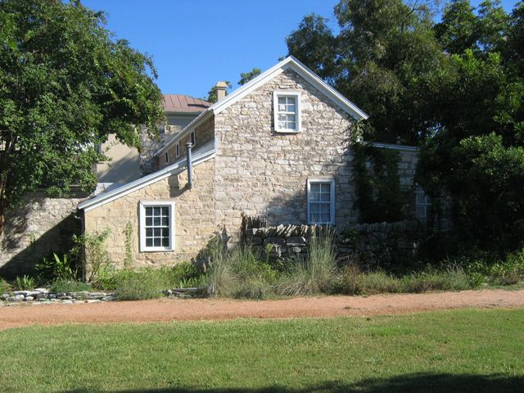 | 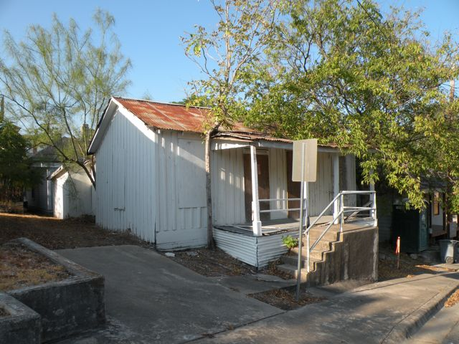
Texas Vernacular House. | Texas Vernacular House.

Many homes constructed in Austin in the nineteenth century are modest properties with no defined architectural style. In the Field Guide to American Houses, Virginia and Lee McAlester call this the National style. Blake Alexander refers to these homes as either Frontier Settlement or Ante-Bellum South architecture in his Texas Homes of the 19th Century. These homes were built using local materials, without formal plans.

- Building Form: Center-passage, L-plan, or two-story center-passage plan.
- Exterior Walls: Various forms of wood siding, including board and batten and weatherboard; limited use of limestone.
- Foundation: Often screened with wood, metal, or stone
- Porch: linear porches across the front of the house, either full or partial width.
- Roof: Gabled.
- Windows: Double-hung wood, often with multi-lite sash and exterior blinds.
- Doors: Typically wood stile and rail.
- Chimneys: Brick or stone, if extant.

The nature of American folk housing changed with the arrival of the railroad in 1871. No longer fully dependent on the local natural resources of timber, limestone, and clay, new materials could be more readily transported to Austin.

Victorian Era Styles

English Victorian

English Victorian
- Chimney: Brick
- 911 East 2nd. St.
- Example language available from American House Styles by John Milnes Baker

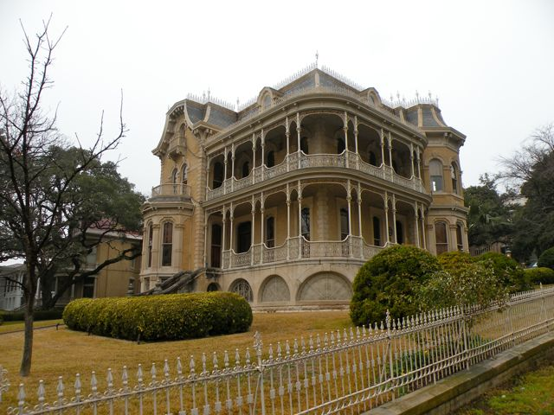 | 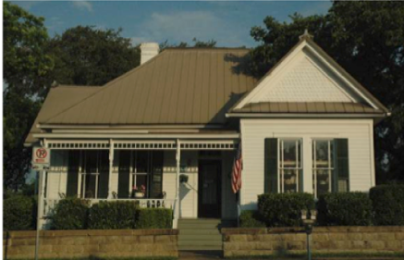
Queen Anne House. | Folk Victorian House.

Queen Anne
- Building Form: L-plan, modified-L, or irregular.
- Exterior Walls: Usually wood siding or wood shingle, but sometimes brick or stone. Often with a variation of materials and textures.
- Foundation: Often screened with skirting of wood, pressed metal, brick, or stone.
- Porch: Feature decorative woodwork, such as turned balusters and spindle friezes. Wraparound porches common. Porch floors often wood and porch ceilings often bead board.
- Roof: Cross-gabled, gable-on-hip, hipped, or pyramidal, often with dormers.
- Windows: Typically double-hung wood sash. Bay windows common character-defining features.
- Doors: Typically wood, often with glazing, transoms, and/or sidelights.
- Chimneys: Commonly brick or stone, often with decorative tapestry brick or corbelling. Sometimes metal stovepipe substitutes for chimney.
- Details: One of the most ornate styles, with fine ornamentation and a high level of detail.

Folk Victorian
- Building Form: L-plan, modified-L, pyramidal-roof-square-plan, or hipped-roof-square-plan.
- Exterior Walls: Usually wood siding or wood shingle.
- Foundation: Often screened with skirting of wood, pressed metal, brick, or stone.
- Porch: Feature decorative woodwork, such as turned balusters and spindle friezes. Porch floors often wood and porch ceilings often bead board. Decorative detail typically prefabricated.
- Roof: Cross-gabled, gable-on-hip, hipped, or pyramidal.
- Windows: Typically double-hung wood sash.
- Doors: Typically wood, sometimes with glazing, transoms, and/or sidelights.
- Chimneys: Brick or stone, if extant. Sometimes metal stovepipe substitutes for chimney.

Early Twentieth-Century American Styles

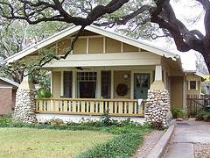
Craftsman House.

Craftsman
- Building Form: L-plan or bungalow.
- Exterior Walls: Typically wood siding or asbestos shingle, sometimes brick. Sometimes feature wood shingle detailing.
- Foundation: Typically skirted with wood or brick. Skirt walls sometimes battered.
- Porches: Partial-width or full-width, often with front-gabled roof, typically supported by tapered wood or stone columns but sometimes supported by decorative metal posts.
- Roofs: Low-sloped hipped or gabled, with deep eaves, often with exposed rafter ends.
- Windows: Typically double-hung wood sash, often with wood screens with geometric detail.
- Doors: Typically wood with glazing, sometimes with transoms and sidelights.
- Chimneys: Brick, sometimes with corbelling or stone coping.

4. Local Residential Historic District Design Standards

A. General
All work requiring a Certificate of Appropriateness within the District will follow the design standards set forth below. The Design Standards are based upon the Secretary of Interior’s Standards for Preservation, Rehabilitation, Restoration, or Reconstruction, as appropriate. These Standards can be found in the Appendix and on the National Park Service website at www.nps.gov/history/hps/tps/standards/standards_complete.pdf.

The following Design Standards clarify the interpretation of the Secretary of Interior’s Standards for application within the District. These standards apply to all contributing properties and new construction within the Local Historic District.

1. Retention of Historic Style:
Respect the historic style of existing resources and retain their historic features, including character-defining elements and building scale and massing, as described in the Architectural Character section of these Design Standards. Avoid alterations to the original fabric of historic buildings. Work undertaken to remove non-historic alterations that detract from original historic style is encouraged.

2. Avoidance of False Historicism:
Do not add stylistic elements that were not originally present, as evidenced by historic documentation. Avoid alterations that have no historic basis and that seek to create the appearance of a different architectural period or a false sense of history. For example, do not add Victorian trim to a Craftsman bungalow or Craftsman details to a 1950s ranch-style house or cottage.

- Sequence of Appropriate Treatment Options:
Treatment for historic materials within the District shall follow the sequence of priorities set forth in the Secretary’s Standards: preservation first, then rehabilitation, then restoration of missing elements if necessary, and, finally, new construction. In order to gain a Certificate of Appropriateness, the applicant shall objectively demonstrate that the proposed project has selected the least intrusive treatment option that is feasible because of the condition of the existing historic materials. (Note that demonstrating financial hardship is a separate and distinct process, set forth in City of Austin Code §25-11-216(D), Ordinance No. 20090806-068).

For additional guidance, the National Park Service publishes the Interpreting the Standards Bulletins and Preservation Briefs, available online at the following sites:

http://www.nps.gov/history/hps/tps/tax/its/itshome.htm

http://www.nps.gov/history/hps/tps/briefs/presbhom.htm

- When to Preserve:
Repair rather than replace deteriorated historic features and architectural elements whenever possible. Many times, materials that initially appear beyond repair may be preserved successfully. Guidelines for the conservation of historic materials are set forth in the Appendix to these Design Standards and are available in National Park Service Preservation Briefs.

- When to Rehabilitate:
If an original architectural feature has deteriorated beyond repair, the replacement shall match the context of the historic feature in size, scale, profile, and finish. The substitution of compatible recycled historic materials is acceptable, provided that the replacement material is compatible with the historic style and character of the resource. In order to be appropriate, synthetic or composite replacement materials shall match the original in size, scale, profile, and finish. Additional recommendations for the rehabilitation of historic materials are provided in the Appendix to these Design Standards.

- When to Restore:
Missing architectural features may be restored using photographs, historic architectural drawings, or physical evidence as a guide. Physical evidence might include other matching elements that remain extant on the building or a “ghost” showing where the missing element historically was attached. The restored element shall match the original in size, scale, profile, and finish. Reconstruction of an entire missing building typically is not appropriate.

- When to Construct New:
New construction within the district is appropriate only if it will not demolish or significantly alter an extant contributing resource. For example, new construction may be appropriate on an empty lot or to the rear of a contributing resource.

4. Architectural Barriers and Accessibility
When needed or required, accessibility to historic properties can be achieved with careful and creative design solutions. Ramps, lifts, and accessible entrances should be designed in compliance with applicable standards to avoid damage to character-defining features of a historic building. Contributing buildings may qualify for variances from the Texas Accessibility Standards. Contact the Texas Historical Commission (THC) Division of Architecture and/or the Texas Department of Licensing and Regulation (TDLR) for inquiries regarding the Texas Accessibility Standards.

5. Energy Efficiency
- Construction of any new structures or alterations of existing structures shall be done in such a way as to maximize energy efficiency while maintaining historic character.

- In no case, however, shall the maximization of energy efficiency be used as a reason to demolish a historic, contributing, or potentially contributing structure, or to change a structure in such a way that its historic features are modified or removed. The City of Austin recognizes that protection of our cultural heritage contributes to sustainable communities and preserves the value of embodied energy used in the construction of the building.

B. Rehabilitation of contributing Buildings

1. Façade
- Retain the original elevations of the building that are visible from the public right-of-way. Do not change the character, appearance, configuration, or materials of the façade, except to restore buildings to their original appearance.

Exterior Walls
- Repair damaged exterior wall materials to the greatest extent possible. Replace only those sections that are deteriorated beyond repair. Replace deteriorated wall materials in kind to match existing wall materials.

- Do not apply aluminum, vinyl or other synthetic siding as a replacement or overlay of a primary building material. Artificial siding materials have been documented to cause serious, costly and often irreparable damage to underlying materials and structural members.

- Do not paint masonry that has not already been painted. Moisture may become trapped between the paint and masonry, causing deterioration of the underlying materials and structural members.

Porches
- Front porches are character-defining features for many building forms and architectural styles; any alterations to the front porch must take into account the architectural style of the house.

- Do not enclose a front porch. If a front porch is screened, it shall be performed in such a way that it is reversible and does not damage any historic fabric.

- Repair damaged porch elements in kind whenever possible. If replacement is necessary, replace only those elements deteriorated beyond repair. Replacement elements shall be contextually and stylistically appropriate.

Roofs
- Retain the original roof pitches and profiles on the building, particularly as seen from the street. Avoid adding to the eave height of original roofs.

- Retain historic dormers.

- Maintain original decorative roof elements, such as exposed rafter ends, bargeboards, or cornices. Do not add decorative roof elements that were not historically present.

- In replacing roof materials, consider first the use of the original material and style if it can be determined from photographs or physical evidence. Otherwise, replace with roofing materials identical in appearance to those that historically would have been appropriate for the building form and style as is practical and feasible.

Recommendations:
- Consider replacing any original dormers that can be documented when roof work is done.
- Preserve original gable/attic vents and roof brackets where feasible.

5. Windows and Screens
a. Do not enlarge, move, or enclose original window openings on façades visible from the public right-of-way. Do not add new window openings on façades visible from the public right-of-way. It may be appropriate to restore original window openings that have been enclosed.

b. Retain and restore original windows, window surrounds, and screens unless deteriorated beyond repair. Refer to treatment recommendations for windows included in the Appendix to these Design Standards.

- If original windows or screens are deteriorated beyond repair, replacement windows shall maintain the same size, profile, configuration, finish and details as the original windows. The relationship between the replacement windows, the window surrounds, and the screens (if present) shall match the original.

- If the original windows or screens are no longer extant, replacement windows shall reflect the size, profile, configuration, and finish that are appropriate for the house’s building form and architectural style. The relationship between the new windows, the window surrounds, and the screens (if present) shall be comparable to original examples of houses of a similar style and era of construction within the District. Refer to the Architectural Character section of these Design Standards.

- False muntins inserted inside the glass are not permitted. Matching the profile of the original window requires the use of either:

i. True divided lites; or

- Dimensional muntins placed on the outside of the glass, along with spacers on the inside of the glass that are an appropriate color, material, and thickness, so that the window appears to have true divided lites even when viewed from an oblique angle.

- Although some substitute materials, such as extruded aluminum, may be used for replacement windows, the appearance of the window from the public right-of-way shall closely resemble the original in size, configuration, profile, and finish. Vinyl is not an appropriate substitute material.

Recommendations:
- Storm windows may provide increased energy efficiency without damaging historic windows. Interior storm windows may be used to maintain the historic exterior appearance of the window. Storm windows shall be installed in such a way that they do not damage historic fabric.

6. Doors
a. Do not enlarge, move, or enclose original door openings. It may be appropriate to restore original doors openings that have been enclosed.

b. Steel and hollow-wood doors are not appropriate for main entries within the District.

Recommendations:
- If a replacement door, door surround, sidelight, or transom is necessary, the style, materials, and finish of the replacement shall reflect the style and period of the house. Refer to the Architectural Character section of these Design Standards.

7. Chimneys
- Maintain original chimneys. Refer to treatment recommendations and repair methods for historic materials included in the Appendix to these Design Standards.

- If new chimneys are added, they shall not be visible on the front of the house as seen from the street.

8. Mechanical Equipment
- Locate all new mechanical or energy conservation equipment in a manner that does not obscure the primary view of the building.
- When mechanical equipment must be attached to the exterior wall of the house, do not damage the original exterior wall material. For masonry walls, all attachments shall anchor into the mortar rather than the masonry unit.
- Rainwater collection systems that are visible from the public street must use traditional materials such as metal and wood; use of PVC containers or piping is not permitted within the public view.
- Photovoltaic and solar thermal installations on contributing buildings must be designed to be in scale with the existing structure's roofline, and must not damage historical architectural features or materials. These roof systems must be on the same plane as the roof. The color of the panels must be compatible with surrounding roof materials.
- Locate photovoltaic, solar thermal, wind power, and satellite dishes (external systems) on ancillary/secondary structures or new additions to the maximum extent feasible.
- Wind power systems shall be located to the rear of the site or to new (rear) building additions.

C. Additions to Contributing Buildings

1. Location and Height
Design new additions so that they do not visually overpower the existing building, compromise its historic character, or destroy any significant historic features or materials. Additions shall appear subordinate to the existing house. Locate additions as inconspicuously as possible.

- All character-defining features on exterior façades that are visible from the public right-of-way shall remain intact.

- Retain as much of the historic building fabric as possible in the construction of the addition.

- Design the addition to complement the scale and massing of the original historic building.

- Never locate an addition flush with the original front façade or projecting beyond the original front façade.

  - If the original historic building has a side-gabled, hipped, or pyramidal roof form, additions shall be set back behind the ridgeline of the original roof.

  - If the original historic building has a front-gabled or flat roof form, the minimum setback between the front façade and the addition shall be equal to one-half of the width of the front façade. For example, if the front façade is thirty feet (30’) wide, than the addition shall be set back from the front façade by at least fifteen feet (15’).

- Minimize the appearance of the addition from the public right-of-way facing the front façade.

  - The roof form of the new addition shall not be visible above the ridgeline of the original roof when the front of the historic building is viewed from the street

  - Two-story additions to one-story houses shall be constructed at the rear of the historic building to preserve the original one-story character.

- Design side additions to minimize visual impact and avoid disruption of the compact building patterns in the District. The building’s overall shape as viewed from the street shall appear relatively unaltered.

Recommendations:
- Consider the effect that the addition will have on the existing and neighboring buildings.
- Large additions may be constructed as separate buildings and connected to the existing building with a linking element such as a breezeway.
- Whenever possible, additions should be located behind the original façade of the historic building, be no wider than the original house, and the roof form should not be visible above the ridgeline of the original roof.
- Design one-story additions to one-story houses whenever possible.

Examples of Appropriate Additions
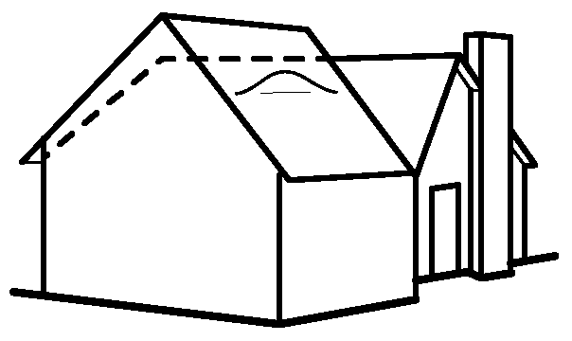 | 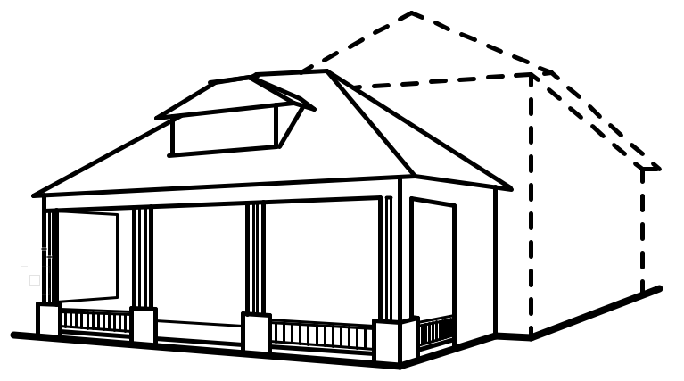 | 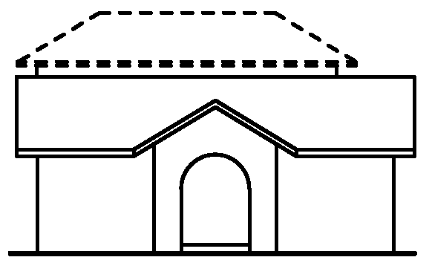 | 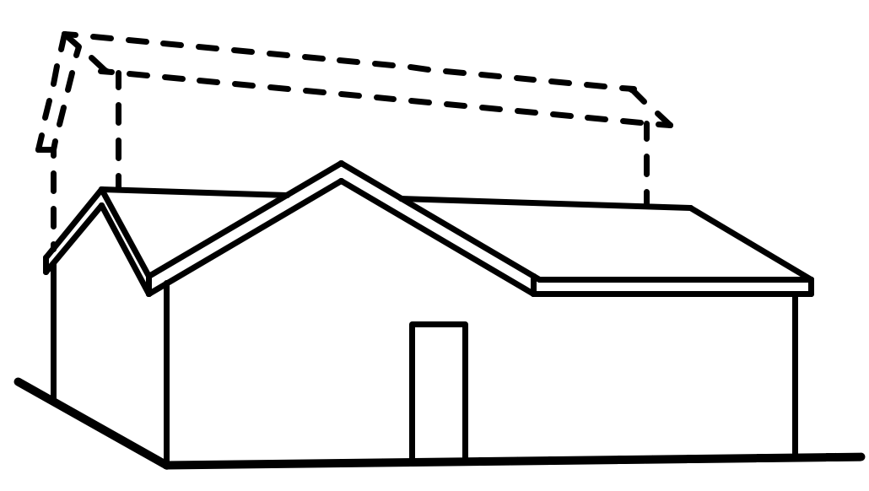
Original roofline illustrated by dotted line. The roof has been elevated slightly and a dormer window has been added, but the original roof form is maintained. The scale of the original house is maintained. | Addition illustrated by dotted line. The addition is set back from front façade and does not destroy or detract from character-defining features of original house. The roof form from original house is reflected in roof form of addition. | Addition illustrated by dotted line. The addition is set back from front façade and does not destroy or detract from character-defining features of original house. The low slope of roof keeps the scale of the addition in keeping with the original house and minimizes the appearance of addition from the street. | Addition illustrated by dotted line. The addition is set back from front façade. The roof form is a simplified version of the original house’s roof, so the addition does not detract from the original.

Examples of Questionably Appropriate Additions
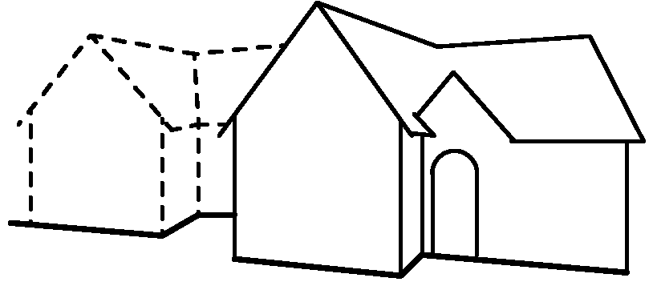 | 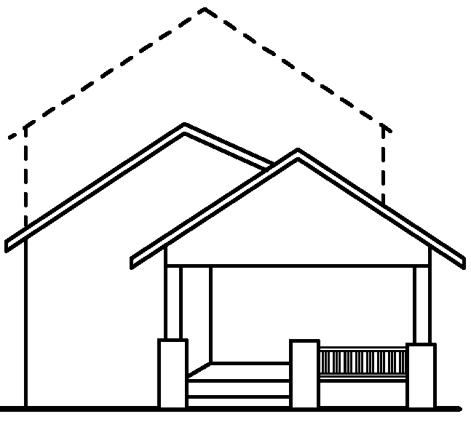 | 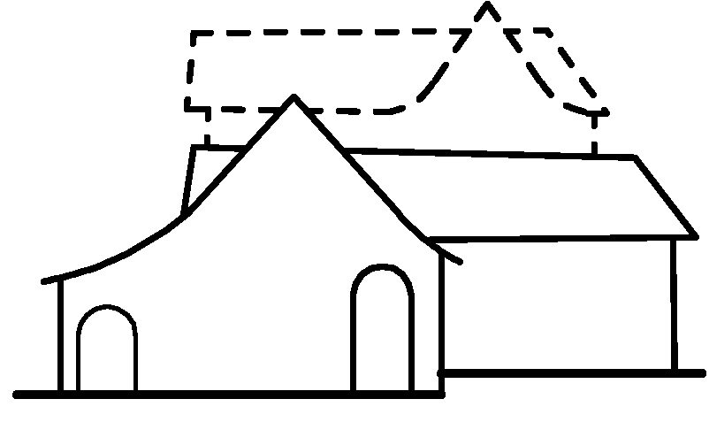
Addition illustrated by dotted line. Although the form of the addition reflects the original house, the addition is set forward almost flush with the original front façade. In order to not detract from the character of the original house, the materials and detailing of the addition must be carefully designed. | Addition illustrated by dotted line. Although the roof form of the addition reflects the original house, the addition is set forward almost flush with the original front façade and changes the overall scale of the house. | Addition illustrated by dotted line. Although the cross-gabled roof form of the addition is inspired by the original house, it competes with the original fabric and may detract from the original house. Because of its large scale, the addition is almost as prominent as the main house.

Examples of Inappropriate Additions
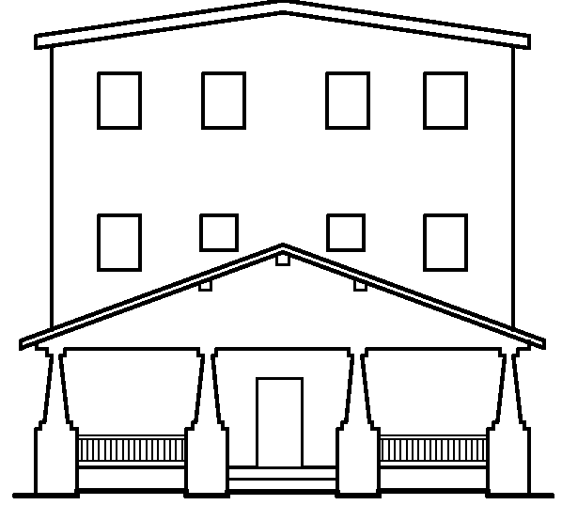 | 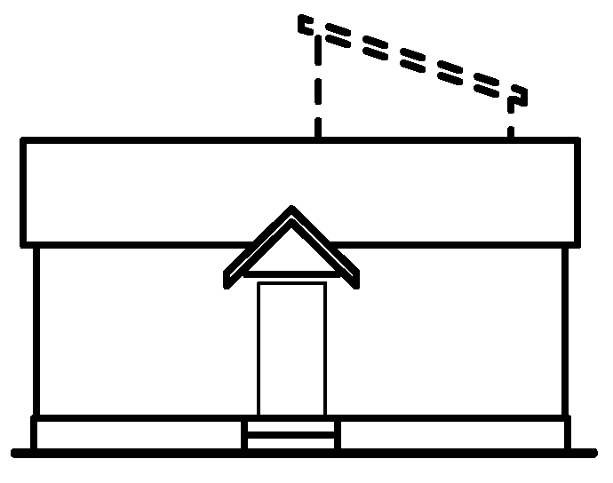 | 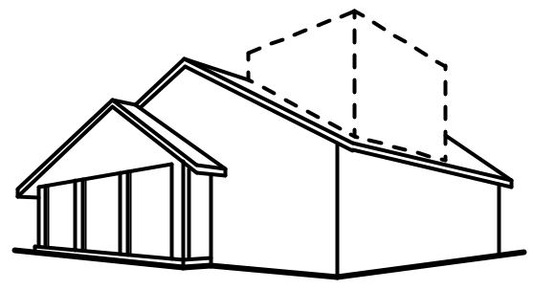
The addition is set forward flush with the front façade. The three-story scale overwhelms the original house. The roof form and fenestration pattern do not reflect the character of the original house. | Addition illustrated by dotted line. Although the scale of the addition is small, the roof form does not reflect the character of the original house. Because the form of the original house is so simple, the addition visually competes with the original house. | Addition illustrated by dotted line. The addition is set forward almost flush with the front façade of the original house. The flat roof is not compatible with the character of the original house. Modern or Contemporary design may be appropriate for an addition, provided that it is not visible from the street.

2. Design and Style
- Additions, though distinguishable from the original structure, do not need to mimic the architectural style of the original historic building, and decorative details that may be confused as historic shall not be added. A contemporary design for an addition is appropriate when the addition is not visible from the street, or if the addition does not overwhelm or obliterate the historic building or its architectural features.

- If an addition will be visible from the street (either from the front or from the side), design the addition to complement the overall proportions and fenestration patterns of the original part of the house. For instance, additions that are visible from the street shall have window-to-wall area ratios, floor-to-floor heights, fenestration patterns, and bay divisions compatible with those on the existing house.

- Avoid windowless walls unless they are character-defining feature found on the original building.

- Creation of usable upstairs space by constructing upstairs dormers on a side or back roof is appropriate provided that it does not affect the appearance of the house from the street. Do not place dormers on a front façade, and minimize the size and scale of dormers on side façades.

3. Exterior Walls
- If an addition will be visible from the street (either from the front or from the side), design the addition to complement the exterior wall materials of the original part of the house, as well as the collective character of the district.

- Differentiate the exterior wall materials of addition from the existing house by means of a hyphen or joint using a different material, varying trim boards, slightly varying dimension of materials, varying orientation of materials, or other means.

4. Porches
- Front porches must be consistent with the architectural style of the house.

- Non-conforming back porches and decks shall not be visible from the street when the house is viewed from the public right-of-way.

- Roofs
- If visible from the street, an addition shall use a simple roof style and slope that complements the roof on the existing house.

- Use materials for the roof that match or are compatible with the roof on the existing house.

- Photovoltaic and solar thermal installations on existing contributing buildings must be designed to be in scale with the existing structure's roofline, and must not damage historical architectural features or materials. These roof systems must be on the same plane as the roof. The colors of the panels must be compatible with surrounding roof materials.

Windows and Screens
- If an addition will be visible from the street (either from the front or from the side), use windows that complement those on the existing house in terms of fenestration pattern, size, configuration, profile and finish.

- For windows on additions, avoid false muntins attached to or inserted between the glass in windows.

- Metal screens may be appropriate for windows in additions. Use anodized or coated metal screens to minimize their visual presence.

Doors
If an addition will be visible from the street (either from the front or from the side), use doors that complement those on the existing house, yet are of a simpler design so that they do not detract from the original main entrance.

Chimneys.
If an addition will be visible from the street (either from the front or from the side), new chimneys shall be made of a material compatible with the original house and shall be of a style and proportion compatible with the building.

D. NON-CONTRIBUTING BUILDINGS

Recommendations:
- A building that is non-contributing to the district because of its age or because it has received unsympathetic remodelings can be renovated in a manner compatible with the architectural style of the building as well as the overall character of the District. The standards provided below for new construction may serve as a guide for alterations to non-contributing buildings.
- Alterations to a historic non-contributing building can be removed to return the building to its historic appearance, based upon physical or photographic evidence.

E. NEW CONSTRUCTION
New construction within the District shall reflect building forms, materials, massing, proportions, roof forms, fenestration patterns, and architectural styles historically present within the District. All current City of Austin codes and ordinances regulating compatibility of new construction shall be followed.

Orientation, Set-Backs, and Height
- New or moved structures shall be positioned on their lot to maintain the existing patterns of the street.

- Front and side yard setbacks shall equal the prevalent setback of the contributing houses on the same side of the street. When the historic street pattern is irregular, new construction shall respond to an adjacent contributing property.

- The height of new construction shall respond to the streetscape and the dimensions of the lot. The height of new construction shall not exceed the height of the tallest contributing building on a similarly sized lot on the block.

Design and Style
- Use massing and scale typical of the contributing structures on the block when designing a new building.

- Character-defining features from different architectural styles shall not be combined eclectically unless such eclectic buildings were prevalent in the District historically.

Recommendations:
- The building forms and architectural styles that historically were present within the District may serve as a model for new construction. Refer to the inventory of historic properties and the Architectural Character section of these Design Standards to determine which building types and styles historically were present within the district. Historical styles that were not present during the District’s period of significance should not be used as a basis for new construction.
- Contemporary design and style is appropriate for new construction in the historic district if the building respects the scale, massing, proportions, patterns, and materials prevalent among contributing houses within the District.
- Pier and beam construction is by far the most common foundation in the District. It is recommended that new construction continue this trend, or, if on a slab, that the slab be raised to the same height as adjacent pier and beam structures.
- It may be appropriate to incorporate compatible architectural features from existing houses on the street, such as porch columns or transoms.

Exterior Walls
- Exterior wall materials used in new construction shall be generally compatible with the collective character of the district in scale, type, size, finish, and texture.

- The pattern and arrangement of secondary materials shall be compatible with the overall character of the district.

Porches
- All new construction is required to have front porches of similar scale and massing to those on nearby structures as per the style guidelines of the East Cesar Chavez Neighborhood Plan.

- Porch posts/columns, railings, and detailing shall correspond to the building form and architectural style of the new building in a way that responds to historical trends. Refer to the Architectural Character section of these Design Standards for further details.

Roofs
- Roofs shall be simple in form, reflecting the character of the roofs on contributing houses within the district.

- Roof forms shall correspond to the building form and architectural style of the new building in a way that responds to historical trends. Refer to the Architectural Character section for further details.

- Roof details such as dormers, eave detailing, and bargeboards shall correspond to the building form and architectural style of the new building in a way that responds to historical trends. Refer to the Architectural Character section for further details.

- Roof materials shall reflect the character of the roofs on contributing houses within the district, as well as the historic character of houses with a similar building form and architectural style.

Windows and Screens
- Windows and screens in new construction visible from the street shall reflect the proportions, configuration, and patterns of windows and doors in historic buildings within the District. The relationship between the new windows, the window surrounds, and the screens (if present) shall respond to historic buildings within the District.

- Windows and doors in new construction shall correspond to the building form and architectural style of the new building in a way that responds to historical trends. Refer to the Architectural Character section of these Design Standards for further details.

- Avoid false muntins attached to or inserted between the glass in windows.

Doors
- Front doors shall be visible from the street.

- Match the style, proportions, materials, and finish of the door to the overall style and design of the house.

Chimneys
- Chimneys in new construction shall reflect the configuration and patterns of chimneys in historic buildings within the District.

- Chimneys in new construction shall correspond to the building form and architectural style of the new building in a way that responds to historical trends. Refer to the Architectural Character section of these Design Standards for further details.

Garages & Accessory Buildings
- Locate detached garages and accessory buildings at the side or rear of new residential structures within the District.

- Design garages and accessory buildings to be compatible in scale for the property and to have an appropriate site relation to the main structure as well as surrounding structures.

- Garages shall be attached only if attached garages historically were appropriate to the building form and architectural style of the new construction. For instance, an attached garage may be appropriate on a new house with a Ranch form, but not a new house with a center-passage form. Refer to the Architectural Character section of these Design Standards.

- Street facing garages are restricted to lots with only street access, and are further restricted to single car wide entry. Materials and finishes used for street facing new garages and outbuildings – including garage doors – shall correspond to the overall character of the district, as well as the building type and style of the new house.

Independent Fences and Walls
- Fences and walls may not obscure the front elevation of the primary structure on the property.

- Fence materials, scale, and finish shall reflect historic trends visible on other contributing houses within the district.

Landscaping
- Preserve existing trees in accordance with the City of Austin Tree and Natural Area Preservation Ordinance.

- Driveways shall be constructed with the most environmentally friendly materials and configurations as possible while maintaining the streetscape pattern historically appropriate to the District.

Recommendations:
- Consider ribbon drives or concrete lattice drives that have a lower impervious cover and improve percolation of rainwater, reduce run-off, and minimize the visual impact of the driveway and parking spaces.
- When constructing a two-story new building or rear addition, consider the use of landscape screening at the back and side property lines to diminish the visibility of the new construction with respect to the privacy of the project property and that of the adjacent property owners.

12. Mechanical Equipment
- Locate all new mechanical or energy conservation equipment to the side or rear of the building.
- Rainwater collection systems should be located to the side or rear. Those visible from the street must use traditional materials such as metal and wood.
- Wind power systems shall be located to the rear of the site or to new (rear) building additions. The color of the turbine must be muted and free from graphics.

Appendix A: Glossary

The following glossary provides definitions for common architectural terms used in these Design Standards. A good reference for illustrated definitions is the Illustrated Dictionary of Historic Architecture, edited by Cyril M. Harris.
Apron: A plain or decorated piece of trim found directly below the sill of a window.
Arch: A curved and sometimes pointed structural member used to span an opening.
Areaway: A sunken area around a basement window or doorway, or mechanical air intake.
Attic: The room or space in the roof of a building.
Awning Window: A window that is hinged at the top and swings outward.
Balcony: A railed projecting platform found above ground level on a building.
Baluster: One of a series of short pillars or other uprights that support a handrail or coping.
Balustrade: A series of balusters connected on top by a coping or a handrail and sometimes on the bottom by a bottom rail; used on staircases, balconies, and porches.
Bargeboard: A board, sometimes decorative, that adorns the gable-end of a gabled roof.
Base: The lowest part of a column.
Basement: The story below the main floor; may be partially or totally below ground level.
Battered Foundation: A foundation that is inclined, so that it appears to slope as it rises upward.
Bay: A space protruding from the exterior wall that contains a bay window.
Bay Window: A projecting window with an angular plan.
Bead Board: Wood paneling with grooves.
Board and Batten: Wood siding with wide boards, placed vertically, and narrow strips of wood (battens) covering the seams between the boards.
Boxed Eaves: Eaves that are enclosed with a fascia and panels under the soffit.
Bracket: A projecting support used under cornices, eaves, balconies, or windows to provide structural or visual support.
Brick: A usually rectangular building or paving unit made of fired clay.
Canopy: A projection over a niche or doorway; often decorative or decorated.
Capital: The uppermost part, or head, of a column or pilaster.
Casement: A hinged window that opens horizontally like a door.
Casing: The finished visible framework around a door or window.
Cement Mortar: A mixture of cement, lime, sand, or other aggregates with water; used in plastering and bricklaying.
Certificate of Appropriateness: The documentation provided by the Historic Landmark Commission after review of proposed changes to a contributing structure in the historic district certifying that the proposed change is in conformance with these Design Standards. The process for obtaining a Certificate of Appropriateness is discussed in the Design Review Process section of these Design Standards.
Clapboard: A thin board, thinner at one edge than the other, laid horizontally and with edges overlapping on a wooden-framed building.
Column: A round, vertical support. In classical architecture the column has three parts, base, shaft, and capital.
Concrete: Made by mixing cement or mortar with water and various aggregates such as sand, gravel, or pebbles
Concrete Block: A hollow or solid rectangular block made of Portland cement, aggregates, and water; used in the construction of walls, foundations, and piers, etc., also called a concrete masonry unit.
Concrete Masonry Unit: Concrete block.
Contributing Resource: A building, structure, or object that contributes to the historic character of the historic district. The district nomination includes an inventory and maps listing all contributing resources.
Coping: The protective uppermost course of a wall or parapet.
Corbelling: Pattern in a masonry wall formed by projecting or overhanging masonry units.
Corner Boards: Boards placed at the corners of exterior walls to finish corners and to protect the ends of the wood siding.
Cornice: In classical architecture the upper, projecting section of an entablature; also the projecting ornamental molding along the top of a building or a wall.
Course: A horizontal row of stones, bricks, or other masonry units.
Crenellation: A parapet with alternating solid and void spaces, originally used for defense; also known as battlement.
Dentil: A small rectangular block used in a series to form a moulding below the cornice.
Dormer: A vertically set window on a sloping roof; also the roofed structure housing such a window.
Double-hung Window: A window of two (or more) sash, or glazed frames, set in vertically grooved frames and capable of being raised or lowered independently of each other.
Downspout: A pipe that carries water from the gutters to the ground or sewer connection.
Eaves: The lower edge of a roof that projects beyond the building wall.
EIFS: Exterior insulation and finish system that resembles stucco, popular in the 1980s – 2000s.
Elevation: An exterior wall of a building; a drawing of a building as seen from a horizontal position.
Ell: An extension that is at right angles to the length of the building.
Engaged Column: A column that is partially attached to a wall.
Entablature: The horizontal beam-like member supported by columns containing three parts: the lower architrave, the middle frieze, and the upper cornice.
Eyebrow Dormer: A low dormer with a wavy line over the lintel, resembling the curve of an eyebrow.
Efflorescence: A growth of salt crystals on a surface caused by the evaporation of water. It typically occurs when water is present on concrete, brick, or natural stone.
Façade: An exterior wall of a building.
Fachwerk: Method of heavy timber framing combined with rubble masonry between the timbers, typically finished with stucco; typically associated with German settlers in Central Texas.
Fanlight: An arched window with muntins that radiate like a fan; typically used as a transom.
Fascia: The flat area or board covering the ends of roof rafters, or other flat areas.
Fenestration: The arrangement of windows and other exterior openings on a building .
Fixed Sash: A window, or part of a window, that does not open.
Flashing: Pieces of metal used around wall and roof junctions and angles as a means of preventing water infiltration.
Flat Roof: A roof that has only enough pitch so that water can drain.
Gable: The triangular upper part of a wall under the end of a ridged roof, or a wall rising above the end of a ridged roof.
Gable Roof: A sloping (ridged) roof that terminates at one or both ends in a gable. A roof formed by two pitched roof surfaces.
Gambrel Roof: A roof having a double slope on two sides of a building. The most common example is a barn roof.
Gazebo: An outdoor pavilion or summer house popular for lawns and gardens of rural houses in the Victorian era.
Gothic arch: An arch that comes to a point at its apex, such as a lancet arch.
Gutter: A channel of wood or metal running along the eaves of the house, used for catching and carrying water.
Half-timbered: Descriptive of 16th and 17th century houses built with heavy timber framing with the spaces filled in with plaster or masonry. This style of building was imitated in the 19th and early 20th centuries in the Tudor Revival style.
Hipped Roof: A roof formed by four pitched roof surfaces.
Hood: A protective and sometimes decorative cover over doors or windows.
Hopper Window: A window that is hinged on the bottom and swings inward.
Jalousie Window: A window composed of angled, overlapping slats of glass, arranged horizontally like a shutter in order to tilt open for ventilation.
Keystone: The central stone of an arch.
Lattice: Open work produced by interlacing of laths or other thin strips, often used as screening, especially in the base of the porch.
Leaded Glass Window: A window composed of pieces of glass that are held in place with lead strips; the glass can be clear, colored, or stained.
Lime Mortar: A mortar made of lime (calcium oxide) and sand, typically used prior to the 1930s, that is more flexible than mortars made of Portland cement.
Lintel: The piece of timber, stone, or metal that spans above an opening and supports the weight of the wall above it.
Lites: Window panes.
Mansard Roof: A roof having two slopes on all four sides; the lower slope is much steeper than the upper.
Moulding: Decorative strip of wood used for ornamentation or finishing.
Mullion: A large vertical member separating two casements or coupled windows or doors.
Muntin: One of the thin strips of wood used to separate panes of glass within a window.
Newel Post: The post supporting the handrail at the top and bottom of a stairway.
Non-Contributing Resource: A building, structure, or object that does not contribute to the historic character of the historic district. The district nomination includes an inventory and maps listing all non-contributing resources.
Paneled Door: A door constructed with recessed rectangular panels surrounded by raised mouldings.
Parapet: A low wall or protective railing, usually used around the edge of a roof or around a balcony.
Patio: A usually paved and shaded area adjoining or enclosed by the walls of a house.
Pediment: A triangular section framed by a horizontal moulding on its base and two sloping mouldings on each side.
Period of Significance: The span of time during which a resource or district was associated with the events that give it significance; for a residential historic district, this period may span from the initial date of development until the date when houses had been constructed on the majority of lots, or when housing construction slowed.
Pilaster: A rectangular column or shallow pier attached to a wall.
Porch: A covered entrance or semi-enclosed space projecting from the façade of a building. May be open sided, screened, or glass enclosed.
Porte Cochere: A roofed structure attached to a building and extending over a driveway, allowing vehicles to pass through.
Portland Cement: A hydraulic cement binder for concrete and mortar; typically not used in construction prior to the 1930s.
Preservation: Defined by the National Park Service as treatment that “places a high premium on the retention of all historic fabric through conservation, maintenance and repair. It reflects a building's continuum over time, through successive occupancies, and the respectful changes and alterations that are made”. (http://www.nps.gov/history/hps/tps/standguide/overview/choose_treat.htm, accessed February 10, 2011).
Pier and Beam Foundation: Foundation consisting of vertical piers set below grade, which support horizontal beams.
Pyramidal Roof: A pyramid-shaped roof with four sides of equal slope and shape.
Quoins: Large or rusticated stone blocks at the corners of a masonry building.
Rafters: The sloping members of a roof upon which the roof covering is placed
Rail: A horizontal bar or beam that creates a barrier at the outer edge of a space such as a porch
Reconstruction: Treatment that “establishes limited opportunities to re-create a non-surviving site, landscape, building, structure, or object in all new materials.”
Rehabilitation: Treatment “defined as the act or process of making possible a compatible use for a property through repair, alterations, and additions while preserving those portions or features which convey its historical, cultural, or architectural values.”
Restoration: Treatment that focuses on the retention of materials from the most significant time in a property's history, while permitting the removal of materials from other periods
(http://www.nps.gov/history/local-law/arch_stnds_10.htm, accessed July 14, 2011).
Retaining Wall: A braced or freestanding wall that bears against an earthen backing
Side Light: A vertical window flanking a door
Sill: Horizontal member at the bottom of a window or door opening
Shed Roof: A roof containing only one sloping plane
Soffit: The underside of an overhanging element, such as the eaves of a roof
Spalling: Small fragments or chips of stone, brick, or stucco that may fall off in layers.
Storm Window: A secondary window installed to protect and/or reinforce the main window
Stucco: Exterior finish material composed of either Portland cement or lime and sand mixed with water
Transom: A horizontal window over a door
Vigas: A heavy wood rafter – especially a rough-hewn log – used to support the roof in Spanish Colonial or Mission Style architecture
Waney-edge Siding: Siding with an irregularly rippled edge, formed by removing the bark but retaining the profile of the wood
Water Table: A projecting ledge or moulding near the base of the exterior wall designed to shed rainwater.
Wing Wall: A portion of the front façade extending past the side façade, often sloping down from the eaves to the ground at an angle

Appendix B: Secretary of the Interior’s Standards for Rehabilitation

1. A property shall be used for its historic purpose or be placed in a new use that requires minimal change to the defining characteristics of the building and its site and environment.
2. The historic character of a property shall be retained and preserved. The removal of historic materials or alteration of features and spaces that characterize a property shall be avoided.
3. Each property shall be recognized as a physical record of its time, place, and use. Changes that create a false sense of historical development, such as adding conjectural features or architectural elements from other buildings, shall not be undertaken.
4. Most properties change over time; those changes that have acquired historic significance in their own right shall be retained and preserved.
5. Distinctive features, finishes, and construction techniques or examples of craftsmanship that characterize a property shall be preserved.
6. Deteriorated historic features shall be repaired rather than replaced. Where the severity of deterioration requires replacement of a distinctive feature, the new feature shall match the old in design, color, texture, and other visual qualities and, where possible, materials. Replacement of missing features shall be substantiated by documentary, physical, or pictorial evidence.
7. Chemical or physical treatments, such as sandblasting, that cause damage to historic materials shall not be used. The surface cleaning of structures, if appropriate, shall be undertaken using the gentlest means possible.
8. Significant archeological resources affected by a project shall be protected and preserved. If such resources must be disturbed, mitigation measures shall be undertaken.
9. New additions, exterior alterations, or related new construction shall not destroy historic materials that characterize the property. The new work shall be differentiated from the old and shall be compatible with the massing, size, scale, and architectural features to protect the historic integrity of the property and its environment.
10. New additions and adjacent or related new construction shall be undertaken in such a manner that if removed in the future, the essential form and integrity of the historic property and its environment would be unimpaired.

Appendix C: Treatment Guidelines

Introduction
This section intends to provide property owners with the most basic of information regarding building material conservation and repair. It is not meant to replace professional architectural, structural, material conservation, or construction consultation.
When seeking professional assistance, be sure to select an architect, engineer, material conservation, or contractor based upon similar, successful past experience and excellent references.
The historic exterior material palette of Austin includes the following materials:
1) Exterior siding:
a) Brick: typically buff colored “Austin Common” brick whose clay was quarried and fired on the banks of the Colorado River and Shoal Creek. The arrival of the railroad on December 25, 1871, brought new materials including other types and colors of brick.
b) Stone: The most common building stone in Austin is limestone. Cordova Cream limestone was used first, and then Cordova Shell became popular in the 1930s. Leuders, Salado, and other types of limestones are also found, but less common. Sandstone (both Pecos red and crème) and granite (Texas red and Tennessee grey) are used to a lesser extent. Some modern buildings utilize marble.
c) Wood: The most common exterior material for Austin homes is wood. Most early homes were constructed of old-growth pine milled from nearby Bastrop. Other exterior grade woods include fir and cypress. Oak, pecan, mesquite, and walnut were generally used for interior finishes. Many of the earliest homes were clad with vertically laid “board and batten” siding. This was followed by many profile design options (shiplap, beveled, Dutch lap, waterfall) laid horizontally.
d) Other: Less common exterior materials for Austin buildings constructed prior to 1970 include stucco, terra cotta, tile, cast stone, and exposed concrete.
2) Roofing:
a) Wood shingle or shake: Most early buildings in Austin had wood shingle (thinner, finer, sawn) or shake (thicker, split wood) roofs. Wood shingle and shake roofs generally last 20 years.
b) Metal: Many forms of metal roofs could be seen in Austin including standing seam, flat seam, and pressed metal shingle systems. Common metals were galvanized steel, tin, terne, lead, and copper. Metal roofs, because they are fairly easy to repair, can last upwards of 50 years or more depending on the material.
c) Slate: Many of the finer homes constructed after 1871 in the Second Empire or Italianate style had slate roofs with metal cresting or decorative ridge caps. Slate roofs, if installed properly with adequate structural support, can last 75-100 years.
d) Tile: Most common at the University of Texas, but also used in fine homes, clay tile roofs use barrel shaped or French (flat) tiles. The most common color for these roofs is dark red or a variegated mix running from dark reds to crèmes.
e) Composition Shingle: Composition and asbestos roof tiles became popular in the United States in the 1930s. Many original asbestos shingle roofs are still in good functional condition.
3) Windows:
a) Wood: Wood is the original material used in window assemblies in the United States. It is easily shaped to a variety of profiles, has high structural strength, and original old-growth wood windows can last upwards of 300 years, if properly maintained. Wood species used in the fabrication of sash were typically tight-grained, old growth wood such as yellow pine, cypress, or fir. These older woods are unmatched in quality in today’s stock: they have higher strength and are more resistance to rot and decay than modern harvested woods.
b) Steel: Rolled steel windows became popular in Austin in the early 1930s. The casement and pivot styles were particularly beneficial in warmer climates, such as Austin, prior to the use of central air conditioning. The higher end of steel sash windows, “Browne Windows,” were equipped with bronze hardware and originally provided with interior bronze screens.
c) Aluminum: Came into use in the 1960s, reflecting modern designs that allowed for larger expanses of uninterrupted glass. The modern curtain wall system is constructed of aluminum. Aluminum windows were a popular replacement to original wood windows. Anodized aluminum windows have an expected life span of 20 years, and repair methods have not been refined. Aluminum is also the most conductive frame material available, and is more prone to condensation in the winter months.
d) Bronze: Typically used in commercial storefronts from the 1890s through the 1960s, there are not many systems of this type remaining in Austin.
e) Glass: Windows are typically glazed with single pane 1/8” clear float glass, back-bedded in the sash and glazed with various types of putties.
f) Awnings: Historic photographs of Austin homes reveal that many west- and south-facing windows were protected by awnings in the earlier part of the twentieth century. Anchors from these awnings are still evident at many buildings. These awnings were drawn to protect the windows during the hot summer months, and retracted during the winter to provide natural warmth to the interior. Awnings have a typical life span of 5-10 years.

B. COMMON CAUSES OF DETERIORATION
The most common source of deterioration in a building is water infiltration. Conditions that allow material decay from water include:
1) cracked or peeling paint;
2) open or deteriorated mortar joints, window glazing, or stucco finish;
3) roof leaks;
4) poor site drainage; or
5) broken windows.
Other sources of deterioration include damage to unpainted wood from sunlight, mechanical damage from impact force, graffiti, foundation settlement due to unstable soils (also related to poor site drainage), and improperly detailed additions and building alterations. The effects of water damage include rot, spalling, mold, efflorescence, and material discoloration.
C. When to PRESERVE and Restore IN PLACE
1) Historic building materials and workmanship are typically higher quality than similar materials and installations found in the market today.
a) Old growth wood used in original construction, in particular, is irreplaceable with modern wood products.
b) Original brick is very challenging and sometimes very costly to match. It is best to prioritize sensitive repair and avoid damage (such as sandblasting or painting) to existing masonry.

D. When to replace Materials
1) Prioritize conservation of original fabric to the maximum extent feasible, and (see above) replace original materials in kind only if they are deteriorated beyond repair.
2) Accurately reconstruct missing elements based on historic documentation
3) Design replacement or elements in keeping with the original property type and architectural style

Wood Siding and Trim
The dimension, texture, profile, and details of original wood siding contribute to the overall historic character of the building and district. The Secretary of Interior’s Rehabilitation Guidelines recommend identifying, retaining, and preserving older and historic exterior wood siding and trim to maintain the historic character of the building.
Recommendations
Consider these facts when evaluating historic wood siding and trim:
- Most wood used on the exterior of older buildings in Austin is old growth pine or cypress. Old growth wood used in original construction is generally tight-grained and more resistant to rot and insects.
- The best way to maintain wood siding and trim is to maintain the paint layer to protect the wood from water infiltration. A sound paint film will keep the wood from absorbing water. Once wood begins absorbing water, it is more prone to deterioration due to rot and insect infestation.
- If original wood siding shows signs of limited rot, it can be repaired using epoxy repair compounds. Epoxy-based liquid consolidants can also be used to strengthen wood and make it more rot resistant where it is vulnerable. Wood that is severely deteriorated can be replaced to match the original appearance in form, installation, and quality. When replacing wood, look for materials that are free of knots, cracks, checks, warping, or twisting. Allow new wood to acclimate to the site before it is installed so that the new wood has a similar moisture content to the original adjacent wood when it is installed. This will reduce the chance of cracking, warping, and twisting of the new wood once it is installed.
- Use of synthetic or composite materials to replace original wood trim or siding should be carefully evaluated on a case-by-case basis. Make sure to compare the rate of expansion and contraction for the proposed material to make sure that it is similar to wood, otherwise the assembly will be vulnerable to open cracks at joints, twisting and warping of composite materials.

Masonry
Masonry includes brick, terra cotta, and any type of stone. The character of the masonry is affected by many things including the type of stone or brick used, the color or color variation, the pattern in which the masonry is laid (running bond, random ashlar, coursed ashlar, etc), and the appearance and detailing of the mortar joints. Most older masonry buildings have the ability to last hundreds of years when properly maintained. Maintaining and preserving all historic masonry building features, whether walls, cornices, or columns, should be the main priority for all preservation projects involving this building material.
Masonry walls and mortar joints should be carefully inspected for signs of deterioration. Masonry is porous and must be protected from water infiltration by maintaining proper roofing, site drainage, and sound mortar joints. Water infiltration causes damage through cycles of freezing and thawing and by carrying salts into the masonry. Cleaning, repointing, and surface treatments must be undertaken with extreme care to avoid permanent damage.
Recommendations
- Inspect masonry walls for signs of cracking, spalling, open joints, movement, discoloration, and interior dampness. Determine the source of problems.
- Reduce or eliminate sources of water around masonry. Keep gutters clean, make sure that downspouts are not leaking, and make sure that the ground slopes away from the building for proper drainage. Long-term exposure of masonry to water will cause deterioration.
- Clean historic masonry using the gentlest means possible. Try different methods and techniques to find the method that works best without causing damage to the surface. Proposed cleaning products should be evaluated to ensure that they are compatible with the type of masonry to be cleaned. Often a neutral detergent, light scrubbing, and rinsing with clean water will suffice.
- Large cracks or pieces falling from or missing from historic masonry walls indicate structural concerns that need to be addressed. This may occur if concealed iron anchors are exposed to water, become corroded, and expand, if the stone is uncommonly weak by nature, or if the building is exposed to structural forces such as high clay soils or foundation movement. Where serious cracking or deterioration is observed, consult a structural engineer experienced in historic preservation to investigate possible structural issues.
- Historic masonry should not be painted. Masonry is naturally a breathable material; the moisture level will fluctuate within the walls over time. Painting the masonry will inhibit or stop the breathability of the masonry, and may cause water to migrate to the interior of the building or create pressure at the exterior film, causing “pocking” or spalling of the surface.
- The application of a masonry sealer is generally not recommended, and should only be considered under the advice of an experienced materials conservator. Similar to painting masonry, any sealers prevent the masonry from breathing, and can trap moisture within the wall, which can cause irreversible pocking, cracking, spalling, and masonry deterioration.
- Do not sandblast masonry with any product or media without the qualified professional guidance of an experienced historic preservation professional. Blasting media tends to remove the hard outer surface of stone and brick, leaving the material more porous and vulnerable to accelerated deterioration. The building will look good for a short while, then will rapidly deteriorate.
- Do not cut new openings or remove substantial portions of masonry walls.
- Do not install exterior insulation finish systems (EIFS) over historic masonry.
- Masonry repair and replacement is a complex subject. Repairs should only be performed by those skilled in preservation techniques. The National Park Service has numerous publications to provide guidance (see Appendix).

Brick
Brick vary considerably in color, texture, and quality, depending upon materials and manufacture. Like a loaf of bread, bricks are baked, creating a hard outer crust that protects a soft interior. Although bricks last a long time, they are still vulnerable to deterioration and will rapidly deteriorate without a hard outer crust. Early “Austin Common” brick is more porous than modern hard-fired brick, but that does not mean that it is inferior or cannot perform well for hundreds of years.
- Do not replace sections of historic brick with brick that is substantially stronger than the original brick.
- When repairing a section of a brick wall, match the existing brick in color, size, and texture; and the existing wall in pattern and profile. Tooth new brick masonry into existing. Match existing joints in color, texture, joint size, and profile. Require test panels for approval.
- Remove each cracked or spalled brick individually and replace to match.

Natural Stone
Natural stone varies in composition and durability. Identifying stone type is essential when considering treatment options. Central Texas homes can utilize several different natural stones, each with its own properties and considerations.
Limestone is a very common building material in Central Texas and Austin, with the most common type of limestone called “Cordova Cream.” Found on many historic and contemporary buildings throughout the city, this buttery yellow/white stone readily absorbs water, and while generally a durable stone, there are deterioration problems associated with it. It is likely the most common natural stone used in residential architecture in Austin. Cordova Shell limestone is also used in many Austin homes. Cordova Shell, with visible shells in the matrix of the stone, is actually slightly stronger and less vulnerable to water damage than Cordova Cream.
Granite is a durable, dense building stone that is used in some of the high style homes of the late nineteenth century and in mid to late twentieth century governmental buildings in downtown Austin. Perhaps the most well known type of granite in Central Texas and Austin is the “Texas Pink Granite” from the Marble Falls quarry that produced the stone for the state capitol.
Slate is used as a roof material on some of the high style homes of the late twentieth century, particularly in the Second Empire and Italianate Style.
- When slate is exposed to water for extended periods of time, as may happen with a leaking gutter or poor site drainage, repair or replacement of the deteriorated stone may be required.
- Corroded metal embedded in masonry must be repaired by an experienced contractor in accordance with accepted structural and preservation techniques. When completed, repairs should match the original appearance or the material or surface.

Mortars
Nineteenth century and early twentieth century mortars have a higher percentage of lime in their mix than more modern mortars. The lime creates a cushion for the masonry and allows for slight movement of the building without cracking. There are few masons who are experienced with repairing this type of mortar – be sure to ask for their experience in this area before hiring.
- Repoint only joints that are unsound. Do not remove all joints in an effort to achieve a uniform appearance when repointing. The large-scale removal of mortar joints often results in damage to historic masonry.
- Remove unsound mortar joints carefully with hand tools that are narrower than the joint. Mortar removal techniques should avoid any damage to the masonry. Power tools used in mortar removal have the ability to do significant and irreversible damage to adjacent masonry. Mortar removal processes should be tested before approval to ensure that the craftsman has the abilities needed to perform the work correctly.
- Remove unsound mortar to a depth of two-and-one-half times the width of the joint, or to sound mortar, whichever is greater.
- Use a mortar that is compatible with historic masonry. Replacement mortar should be equivalent to or softer than the original. Modern mortar mixtures tend to be harder than the surrounding masonry, causing moisture to be trapped in the joints and inhibiting the natural expansion and contraction of the masonry.
- Portland cement came into use in Texas around 1910. This added ingredient made mortar much stronger, much less flexible, and changed the color of the mortar to a cold gray. Mortar with a high Portland cement content has a higher strength, but is prone to cracking because it is not flexible.
- Deteriorated, cracked, or missing mortar should be replaced (or “repointed”) to match the original mortar in composition (the ratio of lime:cement:sand), color (which is largely gained from the sand), texture (gained from the grading of the sand and cement), and tooling or shape of the mortar joint (concave, raised bead, struck flush with the surface, etc).
- Do not apply waterproofing or other surface coatings to masonry buildings as a substitute for repointing and general maintenance.
- Never use synthetic caulking compounds to repoint historic masonry.
- Property owners should consult with a masonry restoration professional before undertaking a major repointing project. Property owners should use contractors familiar with historic masonry. Trained material conservators can easily and inexpensively complete historic mortar testing. This is recommended for all large repointing jobs.

Masonry Cleaning
Exterior stone and brick can provide an attractive organic surface for mold or algae growth, especially on the north elevation or in locations that are in shade most of the day. In most cases this staining does not cause damage to the masonry, it is simply unsightly. Other materials including copper, tar, rust, and paint overspray can also stain masonry. Each type of stain requires a different cleaning technique, and most require some form of professional assistance. As noted in the introduction, seek assistance from experienced companies who have dealt with the same issues in previous projects, ask for references, and do not hesitate to ask questions. The wrong decision in masonry cleaning can have irreversible effects.
Recommendations:
- Clean masonry only when heavy soiling causes actual deterioration, not necessarily just unsightly discoloration.
- Use the gentlest means possible when cleaning, such as a low-pressure water spray (100-300 psi) and natural-bristle brushes. Under-clean rather than over-clean.
- Do not blast water at high pressure (over 300 psi). Never Sandblast.
- Thoroughly research the cleaning products being considered to ensure that they are appropriate for the project, or consult with an architect for product recommendations. Most cleaning products are designed for one type of stone or brick. The product that may be best to clean granite, for example, will cause limestone to dissolve. Extreme caution and extensive research is required to select the best products for the project’s particular needs.
- Test cleaning methods in a small area. When possible, allow the test area to weather for several months.
- Repoint first; clean second in order to limit water penetration during the cleaning process.
- Clean masonry when temperatures will remain above fifty degrees Fahrenheit for at least three days after the completion of cleaning.
- Follow all manufacturers’ recommendations for pre-treating, cleaning, and neutralizing the cleaning surface. Severe and irreversible damage will be caused to most brick, sandstone, and limestone with an improperly selected or improperly installed cleaning system. If in doubt, consult a preservation architect or material conservator.
- Consider removing bushes and undergrowth of trees adjacent to the building in order to allow improved air circulation. This will reduce the occurrence of mold and algae growth.
For additional information: Preservation Brief No. 1 - Assessing Cleaning and Water-Repellent Treatments for Historic Masonry Buildings, by Robert C. Mack, FAIA and Anne Grimmer, Technical Preservation Series, National Park Service.

Metals
Metals are typically used for decorative railings, columns, window sash, gutters and downspouts, window and door lintels, and decorative features of the building. Historic metals include cast iron, wrought iron, copper, lead-coated copper, zinc, aluminum (generally post 1940), and steel. As with most other building materials, water provides the greatest source of deterioration to metals.
Recommendations
- Historic metals, such as iron and steel, are generally ungalvanized or have lost their galvanic coating. Iron and steel corrode, rust, and expand in dimension when exposed to water. This corrosion causes cracking when embedded in masonry and concrete, and staining and rot at wood. Rust can be scraped from the metal, then the metal treated with a zinc-rich primer or galvanizing compound to renew the protection of the metal. All exterior iron and steel must be painted.
- Historic copper and lead-coated copper have a naturally occurring oxidation layer that protects the metal from deterioration. These metals can last for 70-100 years, and develop a protective patina that should be maintained.
- Zinc was often used for fine historic details such as applied moldings in soffits and pressed metal panels. Should zinc deterioration be observed, consult with a qualified professional for recommended repairs.
- Aluminum became a popular window and railing material following World War II. Similar to steel, many alloys of aluminum are used in the construction industry. It will corrode in highly acidic or basic environments (exposure to coastal environments, clay soils).
- Avoid galvanic corrosion by separating dissimilar metals.

Windows
Original windows should be repaired rather than replaced in order to maintain the historic integrity of the building, retain typically very high quality materials used in the original construction, and reduce waste. Several measures can be taken to increase the longevity of the original windows so that more costly repairs are not required. These measures include replacement of deteriorated glazing compound and perimeter sealants, proper surface preparation, priming and painting of sash and frames, epoxy repairs to individual elements, installation of clear interior window films, and optional installation of interior storm windows. Where existing window materials are deteriorated beyond repair, individual components or assemblies can be replaced in kind by skilled craftsmen. Typical scopes of repair presented below are categorized by degree of current deterioration.
1) Good condition (should be evaluated for need on a case-by-case basis every 2-3 years):
Maintain sound exterior paint film, sealants, weatherstripping, and glazing compounds, and make minor repairs as needed.
2) Fair condition (usually after 20 years or more of no maintenance):
Work should begin with a test of the window sash and glazing compound for lead and asbestos content. If hazardous, consult with an environmental engineer for appropriate abatement.
Remove loose and unsound paint, and sand edges smooth. For wood sash and frames, repair signs of early rot using epoxy consolidant and filler. Pay particular attention to window sills, which are more vulnerable to rot and deterioration. Avoid nailing mortise and tenon sash joints.
For metal windows, wire brush clean to remove rust and scale, clean hardware, and spot weld loose joints.
Preserve original glass wherever it is in good condition. Aged glass acquires a wavy appearance that most people find very attractive. Where glass replacement is required, backbed glass in glazing compound, and replace deteriorated glazing compound with new putty to match original, allowing compound to cure for at least a month prior to painting (review manufacturer's recommendations).
Mask hardware, prep, prime with an oil-based primer on wood or a red oxide metal primer on metal, and paint window sash and frames with 100% acrylic coatings to match original color. Adjust hardware and repair or replace weatherstripping as needed.
3. Poor condition (usually after 30 years or more of no maintenance):
Test windows for lead and asbestos content. If hazardous, consult with an environmental engineer for appropriate abatement.
Consider removal of sash for off-site treatment if feasible.
Remove and salvage glass. Remove old glazing putty and backbedding.
Remove loose and unsound paint, and sand smooth, making sure to maintain original profiles and sharp edges in the process.
For wood sash and frames, remove rot, pre-treat remaining wood with an epoxy consolidant, and then fill using epoxy filler and sand smooth. Replace severely deteriorated elements in=kind to match original wood species and grain density. Consider the appropriateness of biocide and wood preservative treatments especially at north facing, shaded or otherwise vulnerable locations.
For metal window sash, strip all paint using mechanical removal processes that do not pit or damage the metal. Replace individual sash and frame elements that are severely corroded to the point of delamination. After removing all corrosion, epoxy repair moderately deteriorated elements to rebuild the original material profile. Once repairs are complete and before re-glazing, prime all metal with a rust inhibitive primer, and all wood with a high quality oil-based primer.
Backbed salvaged glass, install new glazing compound to match original profile, and allow to cure for at least a month prior to painting (review manufacturer's recommendations).
Mask hardware, prep and paint window sash and frames with 100% acrylic coatings to match original color. Clean, adjust and lubricate hardware. Replace weatherstripping to form a tight seal.

Energy Efficiency
Single pane glass has an insulating value (R-value) between 0.85 and 0.91, about the same as a ¾” sheet of plywood or 4” of common brick. Double insulating glass has an insulating value two to four times that of single pane glass, defined by the characteristics of the airspace separating the two panes of glass. Single pane windows can be retrofitted with interior storm windows to double their insulating value, and some types of window sash can be retrofitted with insulated glass when desired. However, there are several drawbacks to insulated glass. Insulated glass is far more costly than single pane glass, costing from 2.5 to 3 times as much as single pane glass. When an insulated glass panel breaks from storm damage, vandalism, or accidental damage, a new one must be custom-fabricated, which typically takes 2-3 days to order and 3-4 days to install, whereas simple single pane glass can be replaced the same day. Insulated glass panels with four times the energy efficiency of single pane glass have low-e or tinted glass and argon-filled chambers, making them even more costly to replace to match adjacent elements. Although technology for insulated glass panels has greatly improved in the last decade, seals still break on individual panes, causing the airspace between glass to fill with condensation and permanently cloud. Finally, from a purely environmental perspective, the manufacturing, shipping and handling requirements for insulated glass panels far exceeds those of plate glass. Given the variables affecting glass selection, a careful study of life cycle costs and impacts to historic character should be conducted prior to glass replacement on any project.
As mentioned above, several steps can be taken to improve the energy efficiency of existing windows. According to the U.S. Department of Energy, the three most beneficial steps to improve energy efficiency include caulking and weatherstripping, window treatments and coverings, and interior storm windows.
1) Awnings reduce solar heat gain in the summer by up to 65% on south facing windows and 77% on west facing windows, and are historically appropriate for many architectural styles. Modern awning materials can be more water repellent and mildew resistant.
2) Thorough sealing of windows needs to be balanced with ventilation requirements for the building. It is more desirable, in general, to seal the windows and obtain fresh air for ventilation through a filtered air system. On the other hand, natural ventilation in spring and fall months in Austin can be uniquely accomplished through opening historic windows.
3) Interior storm windows maintain the historic exterior character of the building while improving the thermal efficiency by the window as much as 100%. The exterior-facing side of the storm window can be treated with a low-e coating to further reduce heat gain. Interior storms must be ventilated to prevent excessive heat build up and accelerated damage to the interior face of original windows.
4) New technology is producing completely clear window films that in no way detract from the historic character of a window. These can be used to reduce ultraviolet light by as much as 99% and reduce solar heat gain by as much as 21%. Tinted window films can reduce solar heat gain by as much as 78%, but negatively affect exterior character and indoor light quality. Window films typically have a 10-20 year life span.

Paint
At its most practical level, exterior paint serves as the outer protective layer that prevents deterioration of wood and metal. In general, unfinished brick masonry should not be painted, and stone masonry should not be painted under any circumstances. Paint seals out moisture when it is sound and tight. A cracked paint surface will allow water to seep into the substrate and be trapped, creating a prime opportunity for substrate deterioration. This substrate deterioration could result in much more costly repairs if left unchecked.
On an aesthetic level, paint enhances the appearance and value of a property. It is often used to enhance architectural features. There is an abundance of information available on appropriate paint colors for historic properties. Many architects, paint suppliers, and publications can provide you with additional information on this topic.
Exterior paint finishes can be expected to last 5-10 years depending on the quality of the paint used, the condition of the substrate materials, weather exposure, and the quality of the application process.
In instances where multiple layers of paint have built up to excess, causing deep paint failure, it may be best to remove them completely. If that is determined the best solution, consider documenting the paint history before stripping. This can be accomplished by a professional, you can sand the layers to create a crater and match the revealed colors to a manufacturer’s paint system, or you can save large paint chips (with all layers intact) in labeled bags for future reference. Test paint for lead content before removal. If lead is present, observe all safety precautions.
Surface preparation is possibly the most important aspect of exterior paint work, and can take from 3 to 10 times the amount of time to actually paint the building. This work should include surface cleaning, removal of all unsound paint, sanding, repair of substrate materials, priming, sealing joints, and finally, painting.
Most exterior paints available today are latex systems. The highest quality latex paints are generally 100% acrylic paints. Oil-based or alkyd paint may be the best option for metals. Latex paints are generally thicker and more flexible; alkyd paints are more brittle. It is important to determine what type of paint is being painted over. If painting over alkyd paint with latex, always sand and prime the entire surface first, because latex will not adhere to alkyd paint. Follow all manufacturers’ instructions to ensure the longest-lasting paint job.
References: Preservation Brief No. 10: Exterior Paint Problems on Historic Woodwork, Kay Weeks and David Look, National Park Service Technical Preservation series.
Recommendations
1) Maintain paint surfaces free of cracks, peeling, mold and mildew to the maximum extent feasible.
2) Test for lead paint on houses that were constructed prior to 1979. Research best practices for worker protection and lead paint management at http://epa.gov/lead/pubs/renovation.htm.
3) Remove loose and unsound paint using the gentlest means possible, and sand surfaces to create smooth transitions between paint layers. Avoid damage to the substrate material.
4) Prime all bare wood and metal with a high quality alkyd primer (latex primers are acceptable for wood, but some say not as good).
5) Seal all open joints with a paintable exterior grade sealant
6) Follow all manufacturer’s instructions for paint finish applications – two thin coats can be better than one thick coat.

Appendix D: Additional Resources

Local Resources
City of Austin Historic Preservation Office:
www.ci.austin.tx.us/historic

Heritage Society of Austin:
www.heritagesocietyaustin.org

University of Texas Historic Preservation:
http://soa.utexas.edu/

Travis County Historical Commission:
www.co.travis.tx.us/historical_commission/default.asp

Austin Convention Center and Visitors Bureau
www.austintexas.org

City of Austin Tree Ordinance
www.ci.austin.tx.us/trees/preserve_code.htm

Austin Energy
http://www.austinenergy.com/

City of Austin Residential Design and Compatibility Standards
http://www.ci.austin.tx.us/zoning/sf_regs.htm

City of Austin Neighborhood Planning
http://www.ci.austin.tx.us/planning/neighborhood/

texas state resources
Texas Historical Commission
http://www.thc.state.tx.us

National Resources
Advisory Council on Historic Preservation (Sources of Financial Assistance for Historic Preservation Projects)
http://www.achp.gov/funding.html

Citizen's Guide to Section 106 Review
http://www.achp.gov/citizensguide.html

General Services Administration
http://www.gsa.gov/Portal/gsa/ep/contentView.do?contentType=GSA_OVERVIEW&contentId=18869

National Archives
http://www.archives.gov/
National Archives rss feed
http://www.archives.gov/news/rss.php

National Coalition for History
http://historycoalition.org/
National Coalition for History rss feed
http://feeds.feedburner.com/historycoalition

National Park Service
http://www.nps.gov

Heritage Preservation Services
http://www.nps.gov/history/hps/index.htm

Preservation Briefs
http://www.nps.gov/hps/tps/briefs/presbhom.htm

National Park Service Cultural Resources
http://www.nps.gov/history

Technical Preservation Services
http://www.nps.gov/history/hps/tps/index.htm

The Secretary of the Interior’s Standards for Rehabilitation
http://www.nps.gov/hps/tps/tax/rehabstandards.htm

Illustrated Rehabilitation Guidelines
http://www.nps.gov/hps/tps/tax/rhb/index.htm

Interpreting the Standards Bulletins
http://www.nps.gov/hps/tps/tax/ITS/itshome.htm

National Register of Historic Places
http://www.nps.gov/nr/index.htm

Laws, Executive Orders & Regulations
http://www.nps.gov/history/laws.htm

Heritage News Blog
http://heritagenews.cr.nps.gov/index/index.cfm

Historic Preservation Grants Division
http://www.nps.gov/history/hps/hpg

Historic Preservation Fund
http://www.nps.gov/history/hps/hpg/HPF/index.htm

Incentives! A Guide to the Federal Historic Preservation Tax Incentives Program for Income-Producing Properties
http://www.nps.gov/history/hps/tps/tax/incentives/index.htm

Save America’s Treasures
http://www.nps.gov/history/hps/treasures/index.htm

Historic Preservation Tax Services
http://www.nps.gov/history/hps/tps/tax/index.htm

National Trust for Historic Preservation
http://www.preservationnation.org

National Trust Preservation Fund (Offers several types of financial assistance to nonprofit organizations, public agencies, for-profit companies, and individuals involved in preservation-related projects.)
http://www.preservationnation.org/resources/find-funding

Public Policy Department’s Advocacy Center
http://www.preservationnation.org/take-action/advocacy-center

Public Policy Weekly Bulletin email alerts
http://www.preservationnation.org/resources/newsletters/public-policy-weeklybulletin/public-policy-weekly-bulletin.html

Center for State and Local Policy
http://www.preservationnation.org/resources/public-policy/center-for-state-local-policy

National Trust for Historic Preservation rss feeds (sign up for all feeds below at the following link)
http://www.preservationnation.org/about-us/press-room/rss.html

Preserve America
http://www.preserveamerica.gov

PreservationDirectory.com
“Preservation Library: articles, regulations and policy”
http://www.preservationdirectory.com/PreservationBlogs/LibraryArticles.aspx

“Legislation & Public Policy Issues in Preservation”
http://www.preservationdirectory.com/PreservationBlogs/ArticleCategories.aspx

PreservationDirectory.com Blog http://www.preservationdirectory.com/PreservationBlogs/ArticleCategories.aspx

Examples of STANDARDS from other cities
Ann Arbor, Michigan
http://www.a2gov.org/government/communityservices/planninganddevelopment/historicpreservation/Pages/Historic%20District%20Commission%20Main%20Page.aspx

Baltimore, Maryland (Sustainability)
http://www.baltimorecity.gov/Government/BoardsandCommissions/HistoricalArchitecturalPreservation/ProceduresandGuidelines.aspx

Harrisburg, Pennsylvania
http://www.harrisburgpa.gov/Resident/DBHD/Planning/Historical_District_Guide.html

New Castle County, Delaware (Windows)
http://www2.nccde.org/landuse/Planning/Historic/Guidelines/default.aspx

Raleigh, North Carolina
http://www.rhdc.org/LocalHistoricDistrictLandmarkServices/DesignReview/tabid/105/Default.aspx

Ripon, Wisconsin (Commercial)
http://www.riponmainst.com/riponmainst/Design%20Guidelines.htm

San Antonio
http://www.sanantonio.gov/planning/neighborhoods/urbandesign.asp?res=1280&ver=tru

Sustainability Resources
The Secretary of the Interior’s Standards for Rehabilitation and Illustrated Guidelines on Sustainability for Rehabilitating Historic Buildings
http://www.nps.gov/history/hps/tps/download/guidelines-sustainability.pdf

Historic Building Energy Efficiency Guide, Boulder, CO
http://www.bouldercolorado.gov/files/PDS/historicpres/HistoricPreservationBrochure_web.pdf

Preservation & Sustainability
http://www.wbdg.org/resources/sustainable_hp.php
http://www.cleanair-coolplanet.org/for_communities/HDCGuide.pdf

National Trust for Historic Preservation Sustainability Information:
http://www.preservationnation.org/issues/sustainability/

Workshops & Seminars
Architectural Heritage Center Educational Programs
http://www.visitahc.org/educationprograms.html

PreservationDirectory.com Preservation Events & Conferences Directory
http://www.preservationdirectory.com/PreservationNewsEvents/NewsEvents.aspx

National Trust for Historic Preservation Conferences & Training
http://www.preservationnation.org/resources/training

Heritage Conservation Network: International Hands-on Workshops for Architectural & Site Conservation
http://www.heritageconservation.net

American Association for State & Local History Workshops
http://www.aaslh.org/workshop.htm

Association for Preservation Technology
http://www.apti.org

Books/publications
Blumenson, John G. Identifying American Architecture: A Pictorial Guide to Styles and Terms, 1600-1945. Alta Mira Press, 1995. 2nd revised edition.

Brand, Stewart. How Buildings Learn: What Happens After They’re Built. New York: Penguin Books, 1994.

Frampton, Kenneth and Yukio Futagawa. Modern Architecture, 1851-1945. New York: Rizzoli, 1983.

Glassie, Henry H. Vernacular Architecture. Philadelphia: Material Culture; Bloomington: Indiana University Press, 2000.

Gottfried, Herbert and Jan Jennings. American Vernacular Design, 1870-1940: An Illustrated Glossary. Iowa State Press, 1988.

Handlin, David P. American Architecture. New York: Thames & Hudson, 2004. 2nd ed.

Harris, Cyril M. American Architecture: An Illustrated Encyclopedia. New York: W.W. Norton, 1998.

——, ed. Dictionary of Architecture & Construction. New York: McGraw-Hill, 2006.

Hess, Alan. Googie: Fifties Coffee Shop Architecture. San Francisco: Chronicle Books, 1985.

Hitchcock, Henry Russell. Architecture, Nineteenth and Twentieth Centuries. New York: Penguin Books, 1987. 4th ed.

——. Modern Architecture: Romanticism and Reintegration. New York : Da Capo Press, 1993.

—— and Arthur Drexler, eds. Built in USA: Post-War Architecture. [New York: Museum of Modern Art, 1952].

—— and Philip Johnson. The International Style. New York: W.W. Norton & Company, 1966.

Jackson, Kenneth T. Crabgrass Frontier: The Suburbanization of the United States. Oxford University Press, 1987.

Longstreth, Richard W. The Buildings of Main Street. Washington, DC: The Preservation Press, National Trust for Historic Preservation, 1987.

McAlester, Virginia and Lee McAlester. A Field Guide to American Houses. New York: Alfred A. Knopf, 1984. Reprinted 2000.

Pevsner, Nikolaus. History of Building Types. Princeton: Princeton University Press, 1976.

Poppeliers, John. What Style Is It? A Guide to American Architecture. New York: John Wiley and Sons, 2003. Rev. Ed.

Roth, Leland M. American Architecture: A History. Boulder: Westview Press, 2001.

Scully, Vincent J. American Architecture and Urbanism. New York: Henry Holt & Co., 1988. Rev. ed.

Trachtenberg, Marvin and Isabelle Hyman. Architecture, from Prehistory to Postmodernity. New York: Harry N. Abrams, 2002.

Upton, Dell, ed. America's Architectural Roots: Ethnic Groups that Built America. Washington, DC: Preservation Press, 1986.

——. Architecture in the United States. Oxford; New York: Oxford University Press, 1998.

Whiffen, Marcus. American Architecture Since 1780: A Guide to the Styles. Cambridge: M.I.T. Press, 1992.

http://www.nps.gov/history/hps/tps/standguide/overview/choose_treat.htm, accessed February 10, 2011
Ibid.
Refer to wood and metals sections for more information on repair of substrate materials.

