PLAZA SALTILLO DISTRICT REDEVELOPMENT
AN OVERVIEW

Size: Six contiguous blocks on 10 acres will be redeveloped with housing, retail, office and parkland while the one-acre Plaza Saltillo will operate unchanged as a MetroRail station

Location: Bounded by Interstate 35 to the west, Onion Street to the east, East Fourth Street to the south, and East Fifth Street to the north

Owner: Capital Metropolitan Transportation Authority

Developer: Endeavor Real Estate Group and Columbus Realty Partners

Objectives: • Provide affordable and market-rate housing
• Increase transit ridership
• Increase accessibility and connectivity

Background: The 11-acre Plaza Saltillo District served as Austin’s train depot for 100 years until it was abandoned in the 1980s. Capital Metro purchased the property in 1995 with plans to incorporate it into future light rail service. In 1997, Capital Metro leased one acre to the City of Austin for Plaza Saltillo, a Mexican-style plaza named for Austin’s sister city Saltillo, Coahuila, Mexico. Built as a community-gathering place intended to showcase East Austin’s vibrant Hispanic culture, the Plaza is now served by Capital Metro’s Red Line.

COA Zoning: “Transit Oriented Development District”

Planning: In 2003, Capital Metro and the City of Austin hired ROMA Design Group to develop a master plan for the remaining 10 acres of the property with extensive community and stakeholder input. In 2006, ROMA completed the Saltillo District Redevelopment Master plan and the City of Austin subsequently adopted the Saltillo Station Area Plan in 2008, which became effective in 2009, coincidentally with the Saltillo Regulating Plan.

The overarching goal of Capital Metro is to preserve and enhance the unique qualities of the surrounding neighborhood. Development must be implemented through a program that includes both public and private investment with input from the community.

In Q3 2014, the Capital Metro board selected the Endeavor team to redevelop the site through a competitive RFP process. In Q1 2016, the board approved the master development agreement between Capital Metro and Endeavor.

Plaza Saltillo is zoned “Transit-Oriented Development-Neighborhood Plan” by the City of Austin (adopted in 2008). The re-Zoning is requested for (1) the additional height needed to build four functional floors of residential over retail as the Saltillo plans call for, and (2) a seven-story office building that includes first-floor retail on the western side of the project near I-35. The remaining blocks will have two to four floors of residential over retail. A portion of the site lies within an established Capitol View Corridor known as “Pleasant Valley Road at Lakeshore Drive;” however, the development will not interfere with the view corridor.
Proposed Plan: Transit: Capital Metro is shifting the tracks for the Red Line to along Fourth Street, which will allow the land to be developed in accordance with the Saltillo Station Area Plan; the Plaza Saltillo station will not be affected by the redevelopment and MetroRail service with adjacent MetroBus service to continue as scheduled.
BLOCK 6
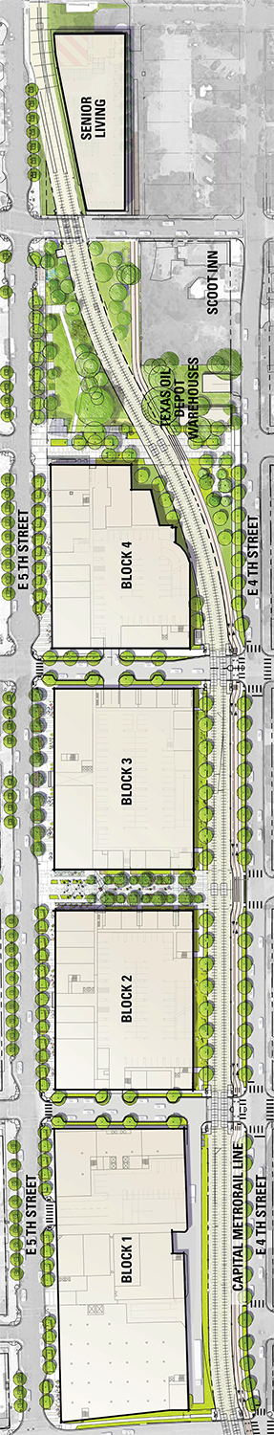
Mobility: In addition to direct access to MetroRail service and extensive bus service, Endeavor will extend the Lance Armstrong Bikeway from under I-35 at Fourth Street to Plaza Saltillo. The development will also include pedestrian-only paseos that will allow neighbors from the north & south to conveniently pass through the property and a B-Cycle bike share station. Reserved Car2Go parking will be provided along with public parking in below-ground facilities. San Marcos Street will also be extended through the project.

Residential: A total of approximately 800 rental units with efficiencies and one- and two- bedroom options are planned in a collection of context-sensitive buildings located above retail, opening onto paseos and blending in with the surrounding residential area.

Affordable Housing: At least 15 percent of all units will be reserved for households that earn up to an average of 50 percent of Austin’s median family income (MFI). Approximately 100 of these residences adjacent to the MetroRail station while the others will be blended into and float within the multifamily buildings.

Retail: More than 110,000 square feet of restaurant/retail space is planned across the site.

Office: A seven-story, 140,000-square-foot multi-tenant office building is planned above retail on the western portion of the site adjacent to I-35, between San Marcos Street and I-35.

Open space: Approx. 1.4 acres of parkland, featuring an open public park, paseos, native landscaping, innovative water quality features and a connection to the Plaza Saltillo rail station will be enhanced for increased connectivity. Additionally, 0.2 acres of private open space will be provided for dog parks on two blocks and 0.6 acres of landscaped, elevated private open space above the parking structures will be provided for residents use all to reduce their impact on surrounding public spaces.

Height: Other than the office building, the buildings will range from two to four floors of residential above retail, totaling three to five stories.

Sustainability: The Project will incorporate sustainable design and construction practices within the buildings and innovative water quality controls across the site. Portions of the project will achieve an Austin Energy Green Building or LEED rating.
Zoning:

